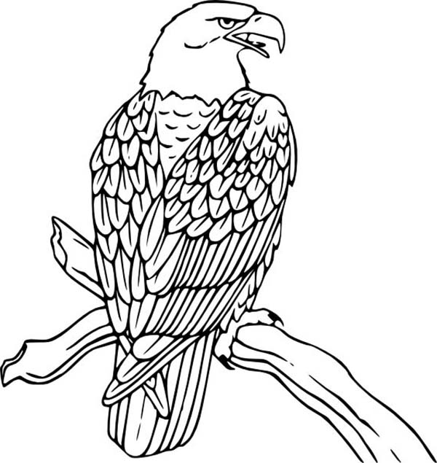

The bald eagle _________________

____________________________

This stands for _ _______________

____________________________