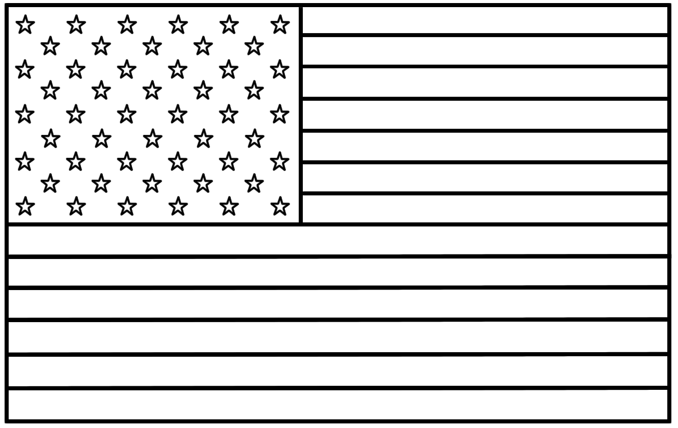

The American flag has ________ _

__________________________ _

This stands for ______________ _

__________________________ _