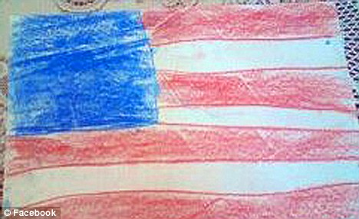
50 ( student would draw a star , 50 or 50 stars)
The American Flag
Stars

Stripes
( student would write) 13 stripes
7 red 6 white

Field
Blue

Student will take their research and draw a complete flag. They would then write facts about the flag in complete sentences.

