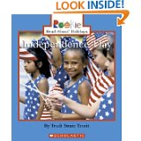

**Title:** Independence Day

**By:** Trudi Strain Trueit

**Vocabulary:** Independence Day, Europe, 13 Colonies, Britain, Boston Harbor, protest, taxes, refused, Revolutionary War 1775, British (red coats), colonists, President Thomas Jefferson, document, Declaration of Independence, July 4, 1776, Philadelphia, Pennsylvania, cannons, flag, honors, freedom, celebrate, barbecues, picnics, marching, parade, Statue of Liberty, New York City, reenactment, Seward, Alaska, Mount Marathon, traditional, fireworks, dazzling, sparklers

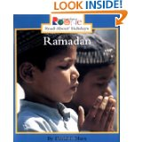

**Title:** Ramadan

**By:** David F. Marx

**Vocabulary:** Ramadan, Muslim, Islam, mosque, Muslim temple, friendship, thinking, fast, promise, three-day celebration, feast

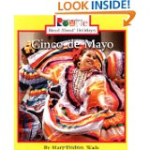

**Title:** Cinco de Mayo

**By:** Mary Dodson Wade

**Vocabulary:** Cinco de Mayo, party, parades, mariachi bands, music, dancers, Fifth of May, Mexico, 1861, free, Benito Juarez – President of Mexico, ruler of France, soldiers, General Zaragoza, Puebla, battle, weapons, army, (May 5, 1862 Battle of Puebla), white blouses, ruffled skirts, sashes, sombreros, carnivals, festivals, piñatas, victory, pride

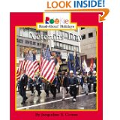

**Title:** Veterans Day

**By:** Jacqueline S. Cotton

**Vocabulary:** veteran, armed forces, Army, Navy, Air Force, Marines, Coast Guard, thankful, November 11, Armistice Day, (World War I ended November 11, 1918), hospitals, parades, march, flags, red paper poppies, battlefields, cemeteries, graves, wreath, Tomb of the Unknowns, Arlington National Cemetery, protect, safe

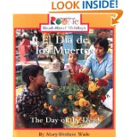

**Title:** The Day of the Dead

**By:** Mary Dodson Wade

**Vocabulary:** Day of the Dead, November 1, cemeteries, celebrate, graves, yellow marigolds, Aztecs, spirits, picnics, hot chocolate, pan de muerto (bread), raisins, icing, skeleton, family history, pictures, candles, glow, sing songs, skull shaped candy, toy skeletons, family

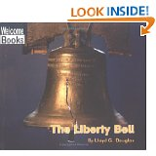

**Title:** The Liberty Bell

**By:** Lloyd G. Douglas

**Vocabulary:** Liberty Bell, American symbol, freedom, 1752, celebrate, constitution, Pennsylvania, Declaration of Independence, 1846, George Washington, crack, space ship, coin

**Page 22 – New Words**

**celebrate** - to do something fun on a special occasion

**coin** – a piece of metal with a picture and a number on it that is used as money

**constitution** – the system of laws in a country or state that tells the rights of the people and the powers of the government

**crack** – a very thin break in something

**Declaration of Independence** – a document declaring the freedom of the thirteen American colonies from British rule

**freedom** – being able to go where you want or do what you want

**liberty** – freedom

**rung** – having made a clear musical sound

**symbol** – a drawing or an object that stands for something else

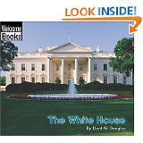

**Title:** The White House

**By:** Lloyd G. Douglas

**Contents:**

1. American Symbol
2. President of the United States
3. Rooms
4. New Words
5. To Find Out More
6. Index
7. About the Author

**Vocabulary:** White House, symbol, president, address, 1600 Pennsylvania Avenue, Washington, D.C., John Adams, Oval Office, East Room, parties, dinners, Easter eggs, front lawn, famous, symbol

**Page 22 New Words**

**address** – the street and town where something is

**Easter eggs** – decorated eggs for Easter

**famous** – known by many people

**Oval Office** – the room where the president works, it is shaped like an egg

**president** – the leader of a country or a group of people

**symbol** – a drawing or an object that stands for something else

**White House** – the place where the president of the United States of America lives

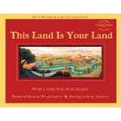

**Title:** This Land Is Your Land

**Words and Music by:** Woody Guthrie

**Paintings by:** Kathy Jakobsen

**With a Tribute by Pete Seeger**

**Book Jacket:**   
“Legendary folksinger-songwriter Woody Guthrie and acclaimed folk artist Kathy Jakobsen invite readers on a captivating journey across America, creating an enchanting portrait of our diverse land and its people. Featuring the complete lyrics and musical notation of “This Land Is Your Land,” as well as a tribute by folksinger Pete Seeger, this classic book celebrates the power of song and its ability to inspire change, and passes on Guthrie’s undying sentiment that “this lans was made for you and me” to a new generation of Americans.”

“This is an ambitious tribute to a popular song that will live as long as the American spirit.” – **New York Times Book Review**

“This effort is what great picture books are all about…Destined to become a favorite…from coast to coast.” – **School Library Journal (starred review)**

“Exuberant… a rich and shifting harmony to a favorite folk song.” – **Horn Book** **(starred review)**

“Stunning, vibrant…This book is a treasure.” – **Booklist (starred review)**

[A] beautiful homage to America.” – **Publishers Weekly (starred review)**

**Lyrics:**

“As I was walking that ribbon of highway,

I saw above me that endless skyway;

I saw below me that golden valley;

This land was made for you and me.

**Refrain:**

This land is your land, this land is my land,

From California to the New York island;

From the redwood forest to the Gulf Stream waters,

This land was made for you and me.

I’ve roamed and rambled and I followed my footsteps

To the sparkling sands of her diamond deserts;

And all around me a voice was sounding:

This land was made for you and me.

**Refrain**

When the sun came shining, and I was strolling,

And the wheat fields waving and the dust clouds rolling,

As the fog was lifting a voice was chanting:

This land was made for you and me.

**Refrain**

As I went walking, I saw a sign there,

And on the sign it said “No Trespassing.”

But on the other side it didn’t say nothing;

That side was made for you and me.

**Refrain**

In the shadow of the steeple I saw my people;

By the relief office I seen my people;

As they stood there hungry, I stood there asking,

Is this land made for you and me?

**Refrain**

Nobody living can ever stop me,

As I go walking that freedom highway;

Nobody living can ever make me turn back;

This land was made for you and me.

**Refrain**

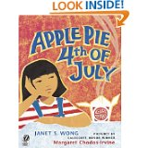

**Title:** Apple Pie 4th of July

**By:** Janet S. Wong

**Pictures by Caldecott Honor Winner:** Margaret Chodos-Irvine

**Book Jacket:**

“No one wants Chinese food on the Fourth of July, I say. We’re in apple-pie America, and my parents are cooking chow mein! They just don’t get it. No one will buy egg rolls. No one will come for noodles. No one – no one – wants sweet-and-sour pork. Americans do not eat Chinese food on the Fourth of July. Right?”

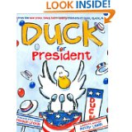

**Title:** Duck for President

**By:** Doreen Cronin

**Illustrated by Caldecott Honoree:** Betsy Lewin

**Book Jacket:** “Our fellow Americans: it is our pleasure, our honor, our duty as citizens to present to you Duck for President. Here is a duck who began in a humble pond, who worked his way to farmer. To governor. And now, perhaps, to the highest office in the land. Some say, if he walks like a duck and talks like a duck, he is a duck. We say, if he walks like a duck and talks like a duck, he will be the next president of the United State of America. Thank you for your vote.”

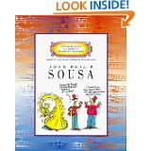

**Title:** John Philip Sousa

**Written and Illustrated by:** Mike Venezia

**Text Highlights:**

* American composer John Philip Sousa was known as the March King.
* John Philip Sousa was born in Washington, D.C., the capital of the United States of America, in 1854.
* He loved his country and wrote some of the most patriotic music ever.
* He is best known for his thrilling marches.
* Familiar titles include: El Capitan, The Washington Post, High School Cadets, Manhattan Beach, King Cotton, and Semper Fidelis.
* These marches are always being played in movies, tv shows, parades, and by school bands.
* John Philip Sousa was amazed with himself when writing a tune – he would just imagine scenes of battles with rifles firing, cannons exploding, clanking of swords, and soldiers marching to the beat of drums and the tune would come to him.
* He composed music for operettas (a short, usually comic play in which the actors sing and dance their parts as the orchestra plays along).
* He was disappointed that his operetta music never became as popular as his marches.
* Military bands made an impression on John Philip Sousa.
* As a boy he took violin lessons, played the trombone, and other band instruments.
* At the age of 13 his father signed him up in the Marine Corps band – he left after 7 years.
* Married, Jane Bellis, and accepted a job as leader of the U.S. Marine Band.
* In 1892, he left to start his own band.
* The idea for his most famous march, The Stars and Stripes Forever, he wrote while traveling on an ocean liner in 1896.
* He lived to be 77 years old.