White House Facts

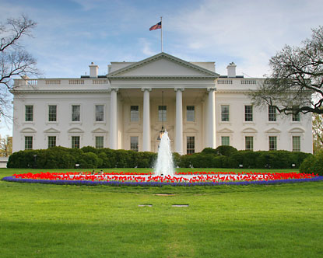

What **I already know** about the White House.