American Flag Facts

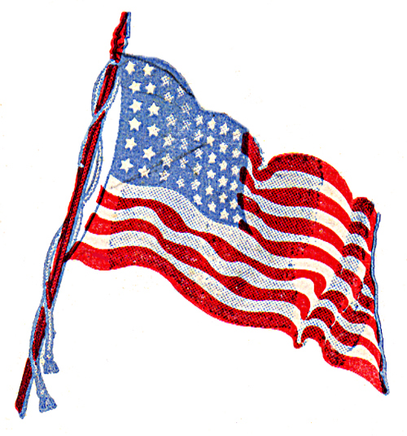

What **I already know** about the American flag.