**White House Facts**

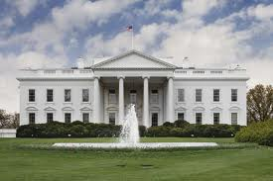

What **I already know** about the White House.