**Statue of Liberty Facts**

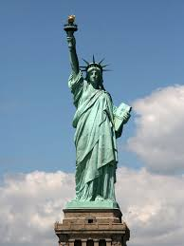

What **I already know** about the Statue of Liberty.