Ramadan Facts

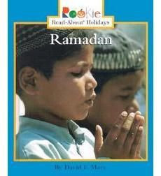

What **I already know** about Ramadan .