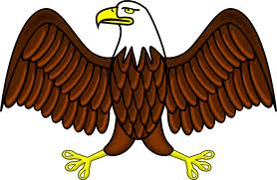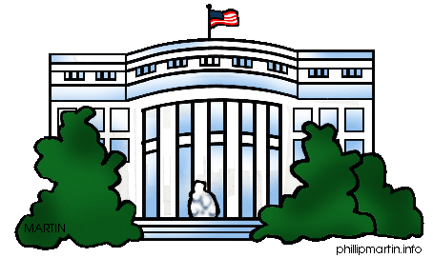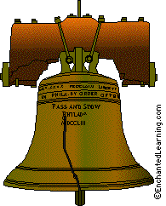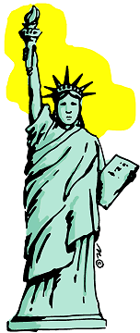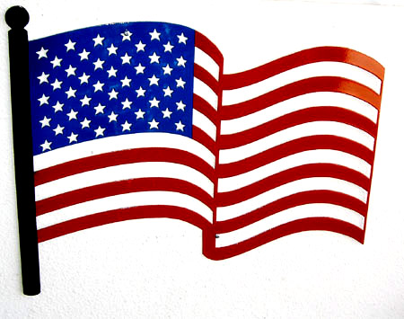

**Name ____________________________________**

**I can identify the main idea and details of a book**.

(RI.K.2)

**Three details I know…**

**I know a lot about…**

**I can write to tell information.**

(W.K.2)

.

Write to tell information.

___________

___________

___________

**I can identify the main idea and details of a book**.

(RI.K.2)

**Three details I know…**

**I know a lot about…**

**I can write to tell information.**

(W.K.2)

Draw a picture.

Write to tell information you know about a police officer.

___________

___________

___________

**I can identify the main idea and details of a book**.

(RI.K.2)

**Three details I know…**

**I know a lot about…**

**I can write to tell information.**

(W.K.2)

Draw a picture.

Write to tell information.

___________

___________

___________

**I can identify the main idea and details of a book**.

(RI.K.2)

**Three details I know…**

**I know a lot about…**

**I can write to tell information.**

(W.K.2)

Draw a picture.

Write to tell information.

___________

___________

___________

**I can identify the main idea and details of a book**.

(RI.K.2)

**Three details I know…**

**I know a lot about…**

**I can write to tell information.**

(W.K.2)

Draw a picture.

Write to tell information.

___________

___________

___________