Diwali Facts

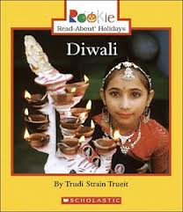

What **I already know** about Diwali .