**Cinco de Mayo Facts**

**[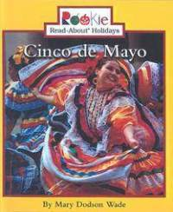](http://www.google.com/url?sa=i&rct=j&q=cinco+de+mayo+by+Trudi+Strain+Trueit&source=images&cd=&cad=rja&docid=BeEZ5_MleB-WPM&tbnid=ipxErDk5biuYIM:&ved=0CAUQjRw&url=http://www.tower.com/cinco-de-mayo-mary-dodson-wade-hardcover/wapi/101527305&ei=OiAMUZvuNsHk2AWEvoDADA&bvm=bv.41867550,d.b2I&psig=AFQjCNH6QSkVjDPhZypLnsDzCcThHL2uFQ&ust=1359835466789339)**

What **I already know** about the Cinco de Mayo.