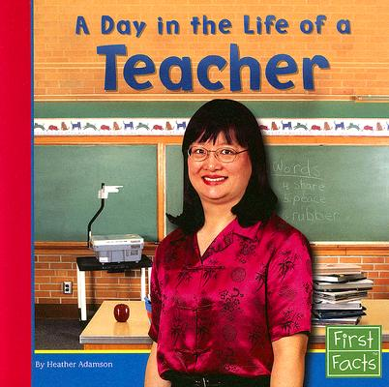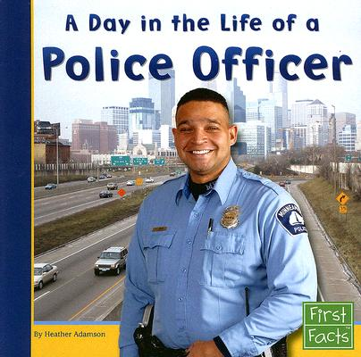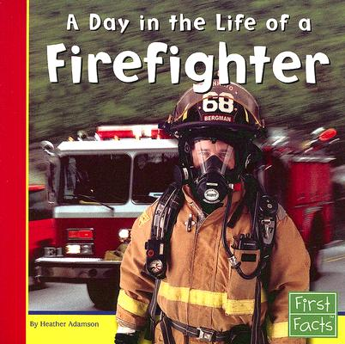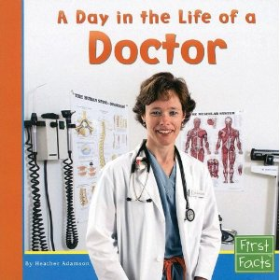

**Name ____________________________________**

**I can identify the main idea and details of a book**.

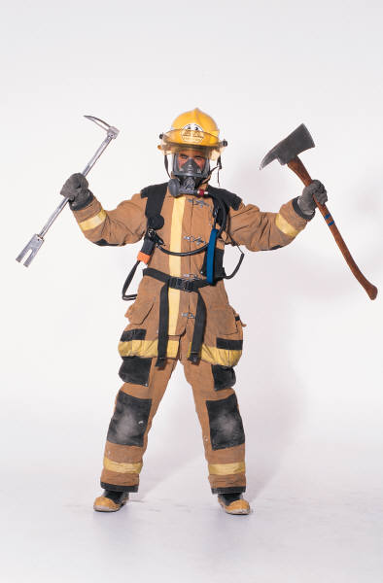(RI.K.2)

firefighter

**Three details I know…**

**I know a lot about…**

**I can write to tell information.**

(W.K.2)

Draw a picture of a firefighter.

Write to tell information you know about a firefighter.

**I can identify the main idea and details of a book**.

C:\Documents and Settings\st\Local Settings\Temporary Internet Files\Content.IE5\RUEOQLYS\MC900056771[1].wmf(RI.K.2)

police officer

**Three details I know…**

**I know a lot about…**

**I can write to tell information.**

(W.K.2)

Draw a picture of a police officer.

Write to tell information you know about a police officer.

**I can identify the main idea and details of a book**.

C:\Users\jkirklan\AppData\Local\Microsoft\Windows\Temporary Internet Files\Content.IE5\Z1A5FH94\MC900390944[1].wmf(RI.K.2)

doctor

**Three details I know…**

**I know a lot about…**

**I can write to tell information.**

(W.K.2)

Draw a picture of a doctor.

Write to tell information you know about a doctor.

**I can identify the main idea and details of a book**.

C:\Users\jkirklan\AppData\Local\Microsoft\Windows\Temporary Internet Files\Content.IE5\Z1A5FH94\MC900128388[1].wmf(RI.K.2)

teacher

**Three details I know…**

**I know a lot about…**

**I can write to tell information.**

(W.K.2)

Draw a picture of a teacher.

Write to tell information you know about a teacher.