*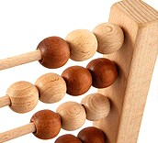Kindergarten, Unit 2*

*Formative Assessment*

This assessment is meant to measure progress towards the following standards:

* RI.K.2 With prompting and support, identify the main topic and retell key details of a text.
* L.K.6 Use words and phrases acquired through conversations, reading and being read to, and responding to texts.

Students are expected to tell what the term “main topic” means. Students will then draw and/or write to tell the main topic of a passage read aloud by the teacher.

Directions for Giving the Assessment:

Read the passage to the students. After reading it through the first time, have students use the box to draw and/or write about the main topic. Read the passage two or three more times as needed.

As students draw and/or write about the main topic, circulate around the room individually asking student what “main topic” means. Students should say that the *main topic* is “what the book is about.” If student answers correctly, check “yes” in the teacher box on the student’s paper.

Ask students what “text” means. Students should say that text is another name for words or print. If the student answers correctly, check “yes” in the teacher box.

Finally, have students circle and color the pictures that are examples of “text.”

Passage:

What animal moves very slowly and carries its home wherever it goes? You guessed it-a turtle! Turtles are known for their hard shells. A turtle can protect itself by pulling its head and legs inside the shell. This makes it hard for an enemy to get the turtle. Turtles do not have any teeth. They use their beak-shaped mouths to tear their food. When the weather gets cold, many turtles go to sleep.

Draw and/or write the main topic.

Tells the definition of “main topic.” Yes

Tells the definition of “text” Yes

Name: ____________________



Circle and color the pictures that are examples of *text*.

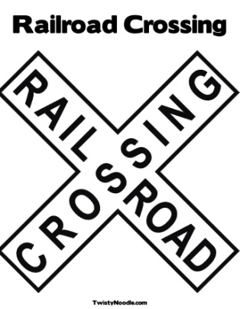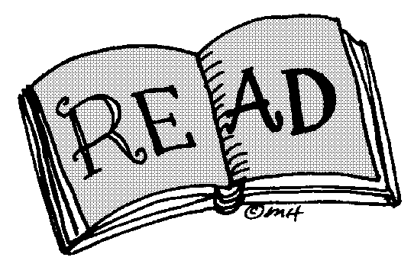

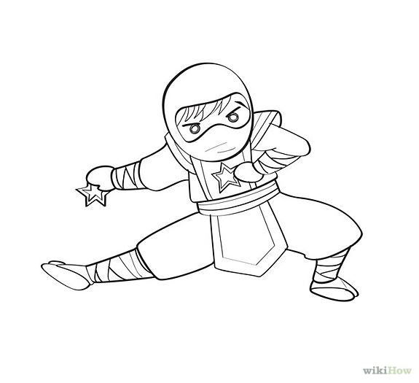



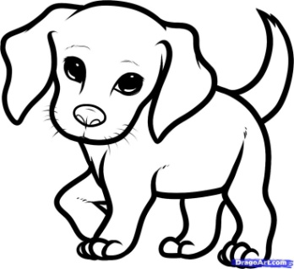

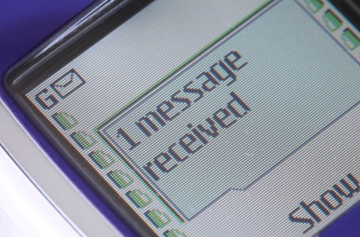

Draw and/or write the main topic.

Tells the definition of “main topic.” Yes

Tells the definition of “text” Yes

Students should draw a turtle. If the drawing is not clear, teachers can ask, “What was the main topic of the story?” If students say “turtles,” students are proficient at this standard at this point in time.

Circle and color the pictures that are examples of *text*.









