Unit 1 Week 3 Shared Reading Daily Lesson Focus
MATERIALS | 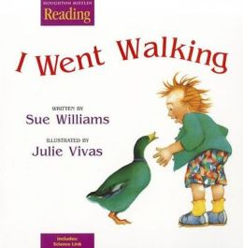  I Went Walking by Sue Williams
DAY | FOCUS
MONDAY | Picture Walk – Answering Questions
TUESDAY | Page-by-Page Progression
WEDNESDAY | Left-to-Right and Top-to-Bottom Progression
THURSDAY | One-to-One Letter/Sound Correspondences
FRIDAY | Begin creating a little book, “I Went Walking.”
Grade Kindergarten Date________________

