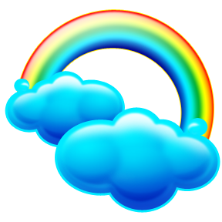**My**

**Book**

**Of**

**Colors**

**Name**_____________

**red**

____apple ____stop sign

____ fish ____ ball

**white**

____snowman ____ghost

____cloud ____cotton ball

**green**

____frog ____turtle

____ grass ____ snake

**blue**

____rocket ____balloon

____ blueberry ____ jeans

**yellow**

____sun ____banana

____ moon ____ star

**orange**

____pumpkin ____orange

____ crayon ____ fish

**gray**

____elephant ____mouse

____ T shirt ____ hair

**purple**

____grapes ____flower

____ bow ____ lollipop

**pink**

____ bubble gum ____pig

____ cotton candy ____ socks

**brown**

____football ____bear

____ table ____ boot

**black**

____ant ____bat

____ tire ____ hat



**A rainbow is** ____,____,

____,____,____,____.