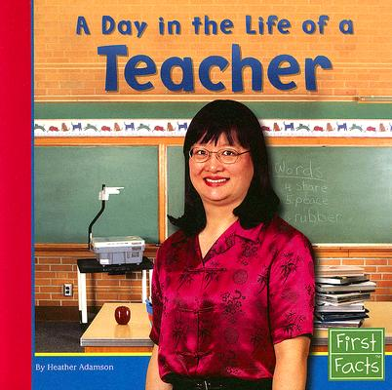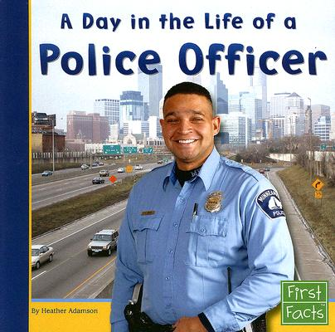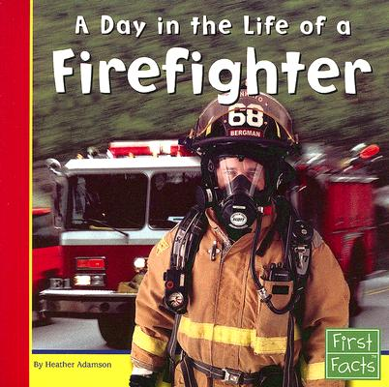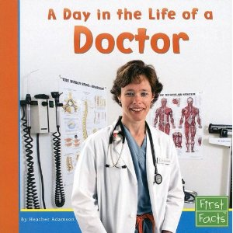

**Name ____________________________________**

My Community Helpers Notebook



C:\Users\jkirklan\AppData\Local\Microsoft\Windows\Temporary Internet Files\Content.IE5\Z1A5FH94\MC900128388[1].wmf

**Conclusion**

**Teachers are very helpful people.**

**Fact**

**Fact**

**Introduction/Topic**

**This text gives information about teachers .**

This text gives information about teachers.

Teachers are very helpful people.



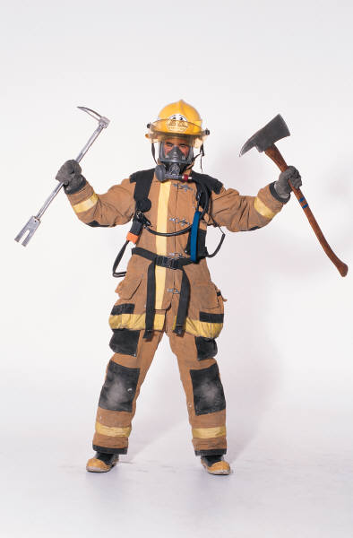

**Conclusion**

**Firefighters are very helpful people.**

**Fact**

**Fact**

**Introduction/Topic**

**This text gives information about firefighters.**

This text gives information about firefighters.

Firefighters are very helpful people.



C:\Documents and Settings\st\Local Settings\Temporary Internet Files\Content.IE5\RUEOQLYS\MC900056771[1].wmf

**Conclusion**

**Police officers are very helpful people.**

**Fact**

**Fact**

**Introduction/Topic**

**This text gives information about police officers.**

This text gives information about police officers.

Police officers are very helpful people.

C:\Users\jkirklan\AppData\Local\Microsoft\Windows\Temporary Internet Files\Content.IE5\Z1A5FH94\MC900390944[1].wmf

**Conclusion**

**Doctors are very helpful people.**

**Fact**

**Fact**

**Introduction/Topic**

**This text gives information about doctors.**

This text gives information about doctors.

Doctors are very helpful people.