Goal: I can write the letter U. I can brainstorm words that have the long U sound.



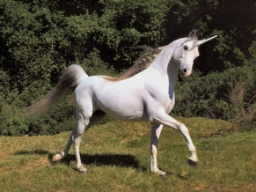 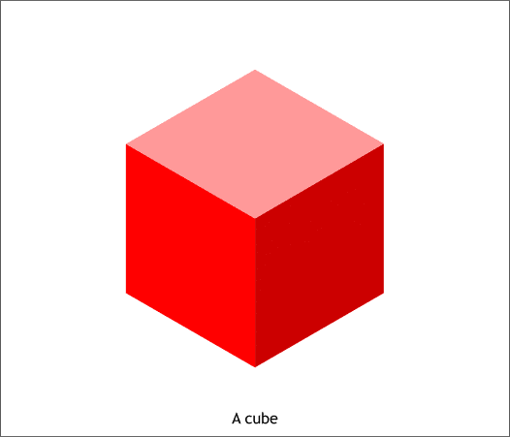

U __ __  
u _____