Kindergarten Name: _________________

Literature

Jack and Katie wanted to make a snowman.  They looked out the window and saw all of the snow on the ground.  They put on their coats, hats, and gloves and headed outside.  Jackson rolled up three balls of snow and stacked them on top of each other.  Katie put on the eyes, mouth, and nose.  Katie and Jackson looked at the finished snowman. He looked awesome!

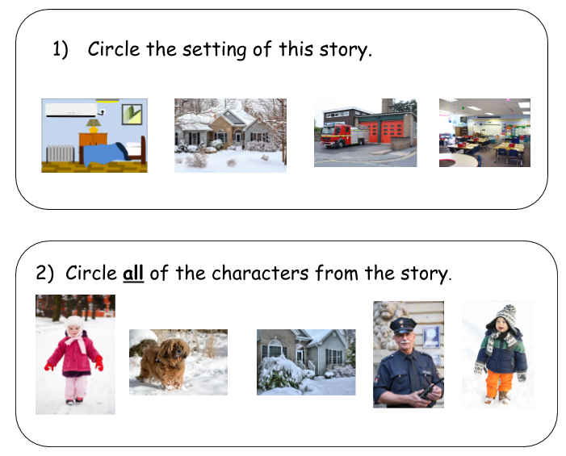

Kindergarten Name: _________________

Literature

Larry is a frog.  Larry is green with brown spots.  He loves to play in the pond.  Sometimes Larry catches flies.  He likes to eat flies for dinner.  After Larry catches flies, he hops around the pond.

