**1st Grade-Literature Name __________________**

DRA 10

**Get Lost**

**By Lesley Jane**

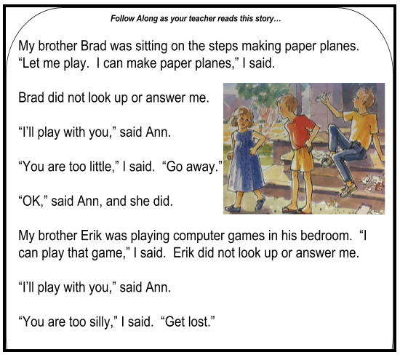

1) Where was Erik making paper planes?

* In his bedroom
* On the steps
* Under the tree

2) Why can’t Ann play computer games?

* She is little.
* She is silly.
* Erik yelled at her.

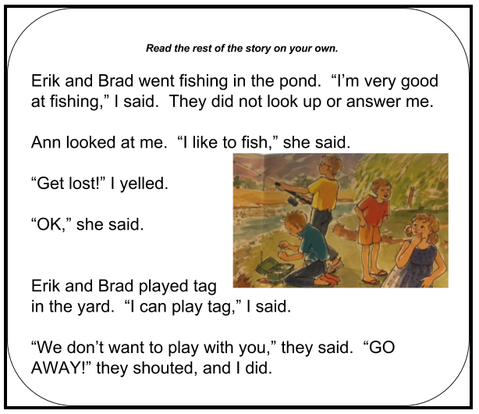

3) Where did Erik and Brad go fishing?

* In the pond
* In the ocean
* In the yard

4) What does Ann like to do?

* Play tag
* She shouts
* Go fishing