**1st Grade-Informational               Name ________________**

**DRA 10**

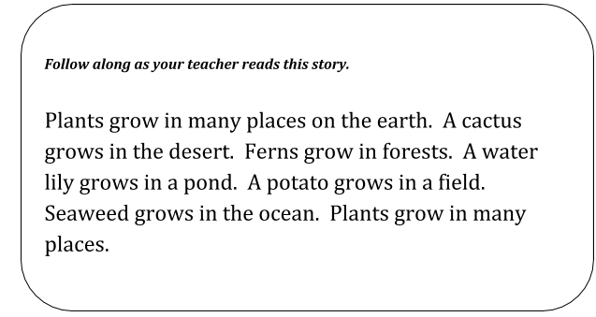

1) What is the main topic of this story?

* Where plants grow
* Forest plants
* Water plants
* Plants around the world

2) Which plant from the story grows in a field?

* Corn
* Potato
* Fern
* Seaweed

3) Where does a cactus grow?

__________________________________________________________________________

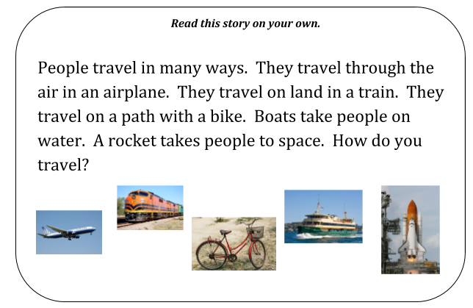

4) What is the main topic of this story?

* Flying in an airplane
* Riding a bike
* Space Shuttles
* Ways to Travel

5) From the story, how do people travel on land?

* Airplane
* Train
* Rocket
* Boat

6) Where do people go in a rocket?

__________________________________________________________________________