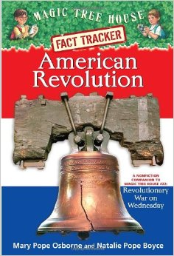American Revolution

Fact Tracker: Chapter 7-8

Writing Task

The patriot soldiers did not have it easy during the war. What things made the war difficult for the patriot soldiers? Use evidence from chapters 7 and 8 to support your answer.

______________________________________________________________________________________________________________________________________________________________________________________________________________________________________________________________________________________________________________________________________________________________________________________________________________________________________________________________________________________________________________________________________________________________________________________________________________________________________________________________________________________________________________________________________________________________________________________________________________________________________________________________________________________________________________________________________________________________________________________________________________________________________________________________________________________________________________________________________________________________________________________________________________________________________________________________________________________________________