

**feeble**

**servant**

**deeds**

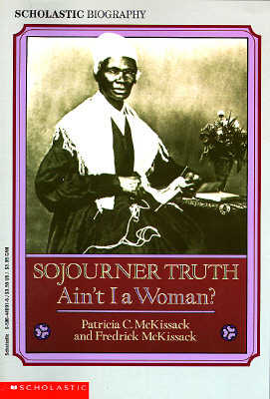

**hardships**

**indentured**

**slaves**



**academy**

**“plum worn out”**

**invented**



**imitating**

**petitions**

**critical**

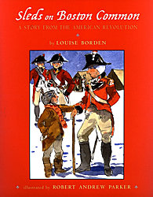

**swagger**

**harsh**

**tyrant**

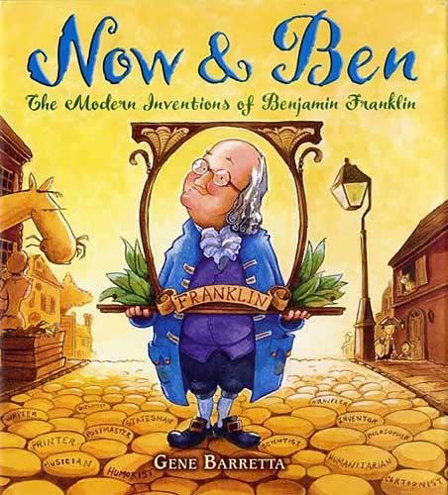

**originated**

**avid**

**efficient**



**defeat**

**surrendered**

**enlist**