**From H is for Horses: An Equestrian Alphabet**

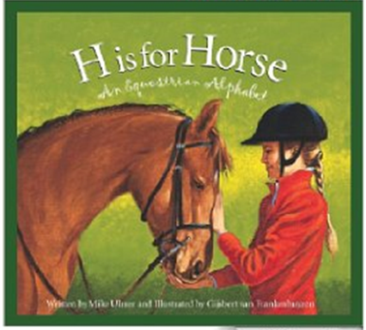**by Mike Ulmer**

The horse was instrumental in setting and bringing law and order to the western United States and western Canada. Canada’s North-West Mounted Police were formed in 1873 and would later be renamed the Royal Canadian Mounted Police. Founded by Stephen Austin in 1823, the Texas Rangers would evolve into an elite crime-fighting organization. Comanche horses are some of the most famous horses in American history.

Horses are herd animals. Despite thousands of years of domestication, horses retain the instincts they need to survive in the wild, long before their relationship began with man. Replaced over the years by gas and diesel engines, harness horses are still treasured by collectors and by scattered groups of small landowners all over the world. Because of their great strength and willingness to work, these horses are known as heavy horses or working horses. The most common harness horse today is the Standardbred, the mainstay of the sport of harness racing.

The quarter horse is the most popular registered breed of horse today and the horse of the old West. Most American communities in the 1800s had a main street about a quarter-mile long. Western horses were known as quarter-mile horses because that was the distance their owners used to race them. A top quarter horse can be faster than a thoroughbred at a quarter mile. There are more than 3.5 million registered quarter horses worldwide and they are known for their intelligence, patience, and ability on the range.

Passage #2: “Big Hope”

This passage is a free download from ReadWorks.org.

Horses are helpful to people in different ways.

Write an essay that explains how two different breeds of horse are helpful to people. Use what you have learned from the excerpts from *H is for Horse* and “Big Hope” to support your essay.

|  |
| --- |
|  |