|  |  |
| --- | --- |
| A | With a partner/partners, turn and talk: What are the parts of a sentence? What does a sentence need/have?  Students will likely say that sentences need/have nouns, verbs, adjectives, capitalization, punctuation, etc. |
| G | I can USE modal auxiliaries. (L.4.1c)  Students will likely say they have no knowledge of modal auxiliaries. |
| N | Tell students that modal auxiliaries are a special kind of verb that they have been using since kindergarten or before…but today we will give it a name.  As a class, work to fill in the blanks on the handout. In the spaces provided, add easy definitions or examples so that students understand the meanings of “necessity,” “uncertainty,” “ability,” and “permission.” Be sure to address the words “mood” and “tense” if these are unfamiliar to students.  Locate and circle modal auxiliaries in the text provided (or an alternate text). Discuss the modal auxiliaries found in the text. |
| A | Turn and Talk: How often do you think we should use modal auxiliaries in our writing? Why do you think that?  Challenge students to create sentences orally and written that use specific modal auxiliaries. Challenge students to use less familiar modal auxiliaries, such as “ought” or “shall.” |
| G | I can use modal auxiliaries. |

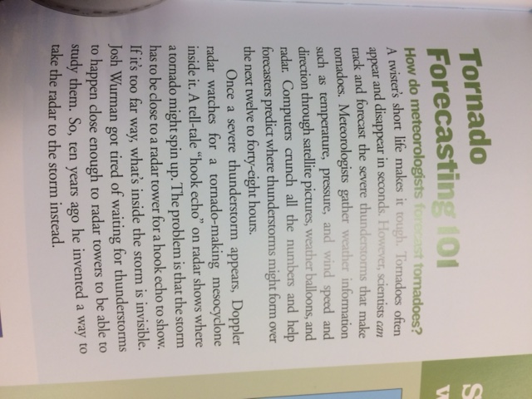A _____________ is a [verb](http://grammar.about.com/od/tz/g/verbterm.htm) that combines with another verb to indicate mood or tense.

A ___________ expresses

necessity (___________), uncertainty (__________),

ability (_______________),

or permission (________________).

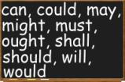

A *modal auxiliary* is a [verb](http://grammar.about.com/od/tz/g/verbterm.htm) that combines with another verb to indicate mood or tense.

Happening in the Past, present, or future

A feeling

A *modal auxiliary* expresses

necessity (something you need), uncertainty (not sure about),

ability (can do; know how to do),

or permission (is it ok? Will I get in trouble?).

