Cirrus clouds are white and feathery and they are the highest clouds. They are sometimes called “mares’ tails.”

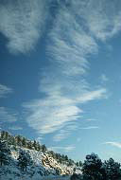

Main Idea: ____________________________________________

Details:

1. _________________________________________________
2. _________________________________________________
3. _________________________________________________

A summary in your own words:

_____________________________________________________

_____________________________________________________

_____________________________________________________