*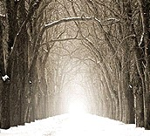4th Grade, Unit 2 Formative Assessment*

This assessment is meant to measure progress towards the following standards:

* RI.4.6 Compare and Contrast a firsthand and secondhand account of the same event or topic; describe the differences in focus and the information in a text or part of a text.
* RI.4.4 Determine the meaning of general academic and domain-specific words or phrases in a text relevant to a grade 4 topic or subject area. (questions 1 and 2)
* RL.4.4 Determine the meaning of words and phrases as they are used in a text, including those that allude to significant characters found in mythology (e.g., Herculean). (Question 6)

Students are expected to define the terms “firsthand account” and “secondhand account.” Students will then determine if a passage is a first- or secondhand account and explain how they know. In future units and assessments, students will compare and contrast accounts in order to meet end of year expectations.

Because we know that vocabulary is typically a tricky spot for our students, three questions have been included to address standards RI.4.4 and RL.4.4

Directions for Giving the Assessment:

Students should spend 10 minutes independently reading the passage and answering the questions on this assessment. Encourage students, especially struggling readers, to think about strategies they have for reading difficult passages/texts.

After 10 minutes, please read the passage and questions aloud for the class. If asked, continue to read aloud any portion of the passage or question. While we know that *read aloud* is not an allowable accommodation on the reading portion of high-stakes testing, the purpose of this assessment is to measure reading comprehension…not independent reading comprehension.

1. What is a firsthand account?

Name: _________________________

_________________________________________________________________

1. What is a secondhand account?

_________________________________________________________________

1. Which of the following are firsthand accounts? Circle all that apply.

Interviews

Text books

Autobiographies

Biographies

Photographs

Speeches

Emails

Encyclopedia

1. Is an article from a newspaper a *firsthand* or *secondhand* account? How do you know?

______________________________________________________________________________________________________________________________________________________________________________________________________

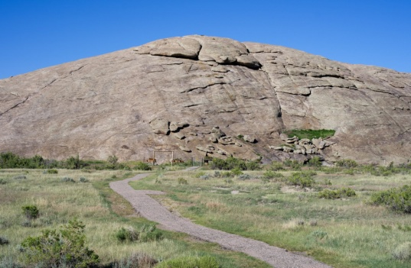Use the following passage to answer the questions below.

July 2, 1849

Passed Independence Rock. This rock is covered with names. With great difficulty, I found a place to cut mine. Twelve miles from this is Devil’s Gate. It’s an opening in the mountain through which the Sweetwater River flows. Several of us climbed this mountain—somewhat perilous for youngsters not over fourteen.… We were gone so long that the train was stopped and men sent out in search of us. We made all sorts of promises to remain in sight in the future.

1. Is this a firsthand or a secondhand account? How do you know?

____________________________________________________________________________________________________________________________________

1. What does the author mean by, “…a place to cut mine”?

______________________________________________________________________________________________________________________________________________________________________________________________________

1. What is a firsthand account?

A description of an event that comes from someone who was actually there

1. What is a secondhand account?

A description of an event based on research; written or told by someone who was not there at the event.

1. Which of the following are examples of a firsthand account? Circle all that apply.

Interviews

Text books

Autobiographies

Biographies

Photographs

Speeches

Emails

Encyclopedia

1. Is an article from a newspaper a *firsthand* or *secondhand* account? How do you know?

A newspaper article can be a firsthand or a secondhand account. It is firsthand if the author attended the event being reported. The article is secondhand if the author is telling about an event that he/she did not attend.

Use the following passage to answer the questions below.

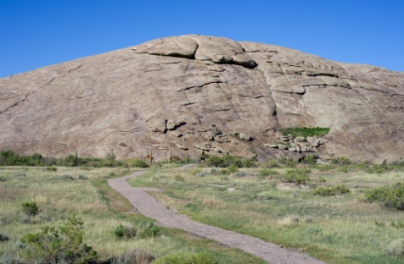

July 2, 1849

Passed Independence Rock. This rock is covered with names. With great difficulty, I found a place to cut mine. Twelve miles from this is Devil’s Gate. It’s an opening in the mountain through which the Sweetwater River flows. Several of us climbed this mountain—somewhat perilous for youngsters not over fourteen.… We were gone so long that the train was stopped and men sent out in search of us. We made all sorts of promises to remain in sight in the future.

1. Is this a firsthand or a secondhand account? How do you know?

This is a firsthand account. The author is writing about something he experienced. He uses the words “I,” “we,” and “us” in his writing.

1. What does the author mean by, “…a place to cut mine”?

The author says that he found a place to carve his name into Independence Rock. He sees that several other names have been placed in the rock, and he has found a place to add his own.