Look at these images of “wily”. Talk with a partner about what you think “wily” might mean.

Read the sentence from the Author’s Note.

Talk with a partner about what you think “wily” means now.

Describe Pete Bruce.

Include his physical appearance as well as his character traits.

You can use drawings and labels or write a series of paragraphs.

Do you think Pete Bruce is wily? Why or why not?

Look at these images of “wily”. Talk with a partner about what you think “wily” might mean.

Read the sentence from the Author’s Note.

Talk with a partner about what you think “wily” means now.

Describe Pete Bruce.

Include his physical appearance as well as his character traits.

You can use drawings and labels or write a series of paragraphs.

Do you think Pete Bruce is wily? Why or why not?

Look at these images of “wily”. Talk with a partner about what you think “wily” might mean.

Read the sentence from the Author’s Note.

Talk with a partner about what you think “wily” means now.

Describe Pete Bruce.

Include his physical appearance as well as his character traits.

You can use drawings and labels or write a series of paragraphs.

Do you think Pete Bruce is wily? Why or why not?

Look at these images of “wily”. Talk with a partner about what you think “wily” might mean.

Read the sentence from the Author’s Note.

Talk with a partner about what you think “wily” means now.

Describe Pete Bruce.

Include his physical appearance as well as his character traits.

You can use drawings and labels or write a series of paragraphs.

Do you think Pete Bruce is wily? Why or why not?



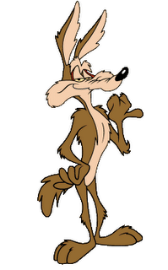

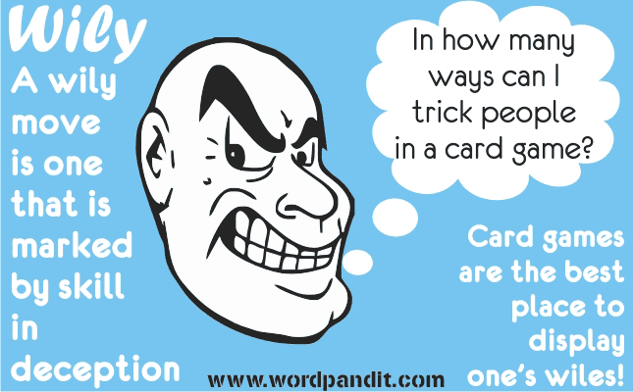

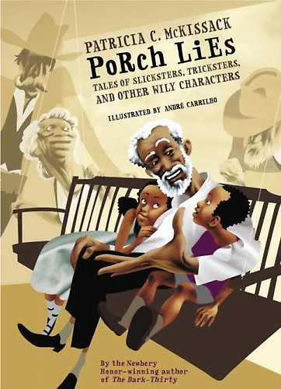I was especially delighted when the story was a slickster-trickster tale about some wily character who used his wits to outsmart his opponents.