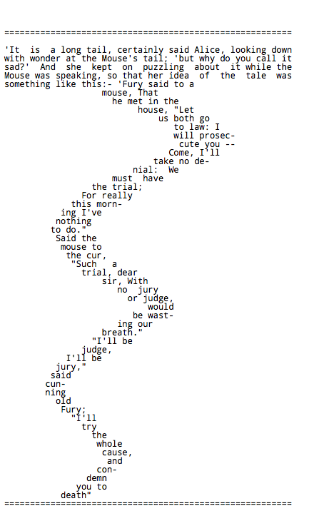

41

31

22

11

6

Common Core State Standards:

* RL.5.2 Determine a theme of a story, drama, or poem from details in the text, including how characters in a story or drama respond to challenges or how the speaker in a poem reflects upon a topic; summarize the text
* RL.5.3 Compare and contrast two or more characters, settings, or events in a story or drama, drawing on specific details in the text (e.g., how characters interact).
* RL.5.4 Determine the meaning of words and phrases as they are used in a text, including figurative language such as metaphors and similes.
* RL.5.5 Explain how a series of chapters, scenes, or stanzas fits together to provide the overall structure of a particular story, drama, or poem
* RL.5.7 Analyze how **visual** and multimedia elements contribute to the meaning, tone, or beauty of a text (e.g., graphic novel, multimedia presentation of fiction, folktale, myth, poem). (Visual Element: the structure of the poem on the page; how it is spaced)
* L.5.4a. Use context (e.g., cause/effect relationships and comparisons in text) as a clue to the meaning of a word or phrase
* L.5.4c. Consult reference materials (e.g., dictionaries, glossaries, thesauruses), both print and digital, to find the pronunciation and determine or clarify the precise meaning of key words and phrases.
* L.5.5c. Use the relationship between particular words (e.g., synonyms, antonyms, homographs) to better understand each of the words.

Vocabulary

The following list of words and phrases is not intended to be a comprehensive list of words that must be explicitly taught in order to fully comprehend the poem. Rather, the list is simply to highlight possible barriers for student comprehension. These words are a combination of Tier II and Tier III words found in the text. Words addressed in a text dependent questions are noted by bold font.

* tail vs. tale
* certainly
* wonder
* puzzling
* fury
* “go to law”
* **prosecute**
* denial
* trial
* **cur**
* **“wasting our breath”**
* cunning
* condemn

About “The Mouse’s Tale”

“The Mouse’s Tale” appears in chapter three of Alice’s Adventures in Wonderland by Lewis Carroll. The following is an excerpt from the conclusion of Chapter 2 of *Alice’s Adventures in Wonderland:*

*So she (Alice) called softly after it, ‘Mouse dear! Do come back again, and we won’t talk about cats or dogs either, if you don’t like them!’ When the Mouse heard this, it turned round and swam slowly back to her: its face was quite pale (with passion, Alice thought), and it said in a low trembling voice, ‘Let us get to the shore, and then I’ll tell you my history, and you’ll understand why it is I hate cats and dogs.’*

Text Dependent Questions

Provide students with their own copy of the poem. Before engaging students in the text dependent questions, all students time to read and process the poem on their own or with a small group. As students discuss the text with their group, circulate around the room noting any unexpected areas of difficulty. Have students to process and discuss the text without assistance from the teacher or other adults. Instead, have students note any questions they have about the text including unknown words.

1. What do you notice about the way the poem is spaced on the page?

* The poem begins with a paragraph and then changes to short lines that zig and zag across the page.
* The poem is shaped like a mouse’s tail.

1. How does the shape of the poem relate to the poem’s title?

* The title of the poem is “The Mouse’s Tale.” Used this way, t-a-l-e means a story. The poem is shaped like the tail of a mouse. When spelled that way, t-a-i-l is a part of an animal’s body.
* *Tail* and *tale* are homophones.

1. Who are the characters in the poem?

* The characters are a mouse and “Fury.”

1. What are the characters discussing?

* Fury is telling Mouse that he is going to take him before a judge; take him to trial.

1. Fill in the blank from lines 23-28:

“Said the mouse to the _________, “Such a trial, dear sir, with…”

Option 1: What does “cur” mean? (If anyone knows what it is)

Option 2: Look up “cur” in a dictionary (book form, online dictionary, or co-build dictionary)

Wordsmyth.com: an unpleasant or mean dog, esp. one of mixed breed; a contemptible person; scoundrel; wretch.

[www.collinsdictionary.com](http://www.collinsdictionary.com): A **cur** is an unfriendly dog, especially a mongrel

How does this definition support mouse’s feelings towards Fury? What do we now know about Fury?

* Fury is a dog. Mouse hates dogs (evidence from the excerpt from chapter 2), and Fury is no exception. Mouse despises him.

1. What does Fury tell the mouse he will do at the trial?

* Fury tells mouse that, at the trial, he will be both the judge and the jury.
* According to the text, Fury with *prosecute* mouse.

1. What does prosecute mean as it is used in lines 11-12? Explain your thinking with evidence from the text.

* Prosecute means to take legal action again, to take a person to court.
* Key Words: trial, judge, jury, go to the law

1. What does Mouse mean when he uses the phrase “wasting our breath”?

* Mouse means that going to trial without a judge and jury would not solve the problem that he is having with Fury. Without someone in charge, he and Fury will not be able to come to an agreement.

1. Why does Fury want to be the Judge and the Jury? What do his words tell us about him?

* As the judge, Fury will decide whether or not mouse is guilty. As the jury, Fury will decide the punishment if mouse is found guilty.
* The dialogue between mouse and Fury let us know that Fury is cunning and sly. He does not like mouse. In fact, he despises him and wishes him dead.

1. Will this be a fair trial? How do you know?

* No, this will not be a fair trial. From the first few lines of the poem Fury tells mouse that he will “prosecute” mouse and “…condemn you to death.” He has decided his verdict and punishment before the trial ever begins.

1. According to Mouse, this poem is meant to tell why he hates cats and dogs. Does the text do what is intended? Support your response with evidence from the text.

* Responses to the question above will vary. In general, students can infer that Mouse hates dogs because Fury is unfair and mean. Mouse seems to be judging all dogs on his interactions with Fury. The poem does not tell why Mouse hates cats.