*Read the passage. Then answer multiple-choice questions 1 through 8 and the open-response question.*

Mary Anderson: Windshield Wipers

An excerpt from Girls Think of Everything: Stories of Ingenious Inventions by Women by Catherine Thimmesh

It was a dreadful day, weatherwise. Snow and sleet pelted the pavement, and people burrowed deep within their coats. Hoping to catch the sights and escape the blustery cold, Mary Anderson of Birmingham, Alabama, climbed aboard a New York City streetcar. The year was 1902. It turned out to be a ride she would never forget, but not because of the scenery. Instead, the ride would inspire her to invent the very first windshield wiper. And simply because she felt sorry for the streetcar driver, who struggled to see through the glass. The invention would not only improve conditions for all drivers, but would save countless lives as well.

1. Earlier, top-notch engineers had tackled the problem of poor visibility in bad weather and came up with a solution. They split the windshield. Once the glass became covered with rain or snow, the streetcar driver could fling open the middle for a clear view. Trouble was, it didn’t work. At least not very well. Mary watched helplessly as the driver desperately tried to see. When he opened the split glass, he was greeted with a burst of icy cold air and a blast of heavy, wet snow.

2. *“Why doesn’t someone create a device to remove the snow?” Mary reportedly asked the people around her.*

3. *It’s been tried many times,” they told her. “Can’t be done.”*

4. Nonsense, thought Mary, as she scribbled in her notebook. Why can’t there be a lever on the inside that would move an arm on the outside to swipe off the snow? To her, it seemed perfectly simple.

5. Later, when she returned to her home in Birmingham, she studied her sketches. She spent some time refining her drawings – making them more elaborate, adding more details. Satisfied at

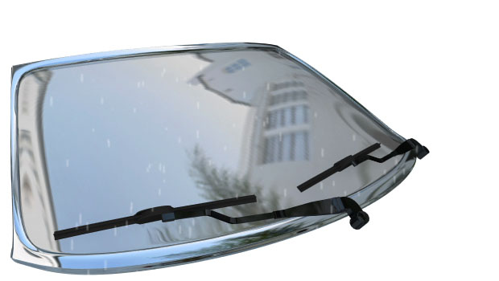

last, she brought her design to a small manufacturing company in Birmingham and hired them to make a model. Then, she filed a patent application.

6. *“My invention relates to an improvement in window-cleaning devices in which a radially-swinging arm is actuated by a handle from inside of a car-vestibule,” Mary stated in her patent specification.*

7. In other words, a lever on the inside that would move an arm on the outside. Mary’s wiper was made of wooden strips and pieces of rubber. She designed it to be removed in good weather so that it would not interfere with the appearance of the streetcar. One of her most important elements was the addition of a counterweight.

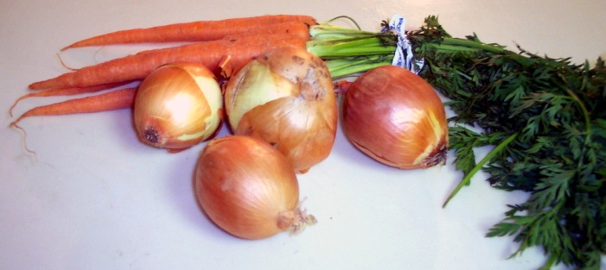 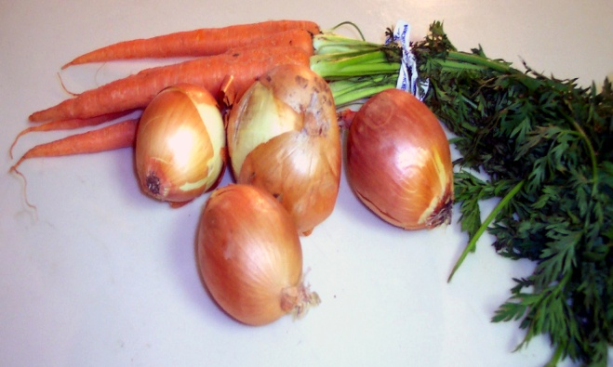

*Before windshield wipers were widely available, drivers used to smear pieces of carrots or onions across the glass to create an oily film that they hoped would repel water.*

10. Mary put the patent in a drawer and, eventually, it expired. Several years later, someone else revived her idea, patented it, sold it, and made a very large sum of money. Every day, lives are saved due to increased visibility during bad weather. Even in our high-tech society, the windshield wiper remains one of the greatest safety inventions of the modern-day automobile. And tourists can now see the sights despite the snow, sleet, or rain.

8. *This was used, she writes, “to provide means for maintaining a uniform pressure upon the glass throughout the entire area swept by my improved window-cleaning device.”*

9.In other words, it would swipe off the snow. Mary was awarded a patent in 1903 for a window-cleaning device – a windshield wiper. Once the invention was protected by a patent, she wrote to a large Canadian company offering to sell her rights. They weren’t interested. After reviewing her proposal, they decided that her invention had little, if any, commercial value. They simply didn’t think it would sell. They encouraged her, however, to submit any other “useful patents” she might have for their consideration.

1

3

Why did a large Canadian company refuse to buy the rights to Mary’s windshield wipers?

**A** They didn’t think many people would buy it.

**B** They thought it cost too much money to

make.

**C** They thought it was unsafe.

**D** They didn’t have the materials needed to

make them.

Based on information in the passage, what is one way that drivers tackled the problem of poor visibility in bad weather before windshield wipers were available?

**A** Drivers would just stick their head out the

window to see.

**B** Drivers would pour hot water on the

windshield.

**C** Drivers didn’t go out in bad weather.

**D** Drivers would fling open the middle of the

windshield to see.

Why did Mary feel sorry for the streetcar driver?

**A** He forgot his glasses at home and couldn’t see

well.

**B** Snow and sleet covered the windshield of his

streetcar and caused poor visibility.

**C** The driver worked in New York City and there

was a lot of traffic.

**D** The streetcar’s windshield wipers wouldn’t

work.

Based on the information in the passage, a reader can tell that a patent is used to –

**A** clean a windshield

**B** build an invention

**C** register an invention as your idea

**D** create ideas for an invention

2

4

8

7

6

Which sentence includes an opinion.

**A** Mary was awarded a patent in 1903 for a

window-cleaning device – a windshield

wiper.

**B** Mary’s wiper was made of wooden strips and

pieces of rubber.

**C** The windshield wiper is the greatest safety

invention ever.

**D** At one time, onions and carrots were smeared

on windshields to repel water.

Which question is answered by the information in paragraph 7?

**A** How did Mary’s windshield wiper design

work?

**B** Why did Mary design a window-cleaning

device?

**C** When was Mary awarded a patent for her

window-cleaning device?

**D** What did Mary do with her sketches of a

windshield wiper?

Which **best** describes the passage?

**A** fantasy

**B** biography

**C** realistic fiction

**D** historical fiction

Below are the main events in the passage.







Which event **best** completes the graphic organizer?

**A** Mary designed a window-cleaning device.

**B** Mary put the patent for her design in a drawer.

**C** Mary traveled to New York City to see the

sights.

**D** Mary used carrots and onions to clean the

streetcar windows.

5

Mary offered the rights to her windshield wiper design to a large Canadian company, but was turned down.

Several years later, someone else used Mary’s windshield wiper idea. Now driving in snow, sleet and rain is safer.

?

Mary Anderson visited New York City and noticed how streetcar drivers had trouble seeing in bad weather.

What are two negative reactions to Mary’s new idea of a window-cleaning device that happened in the passage? How did Mary respond to each of these reactions?

|  |
| --- |
| **________________________________________________**  **________________________________________________**  **________________________________________________**  **________________________________________________**  **________________________________________________** |

Many times people react negatively to new ideas, such as Mary’s invention. Do you agree with what Mary did in response to the negative opinion of her window-cleaning device at the end of this story? Explain and support your opinion.

|  |
| --- |
| **________________________________________________**  **________________________________________________**  **________________________________________________**  **________________________________________________**  **________________________________________________** |