**Our Interview with Mr. Neil Armstrong**

**Introduction**

Mr. Neil Armstrong is the first man ever to set foot on the moon. He kindly allowed us to interview him by e-mail and this is his interview.

*Nadia [N]*

*Neil Armstrong [NA]*

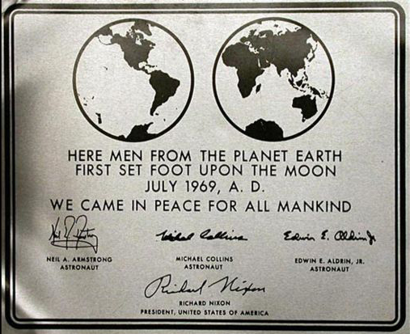

NASA, Public domain ([link](http://commons.wikimedia.org/wiki/Image:Apollo11Plaque.jpg)).

N: How did you feel when you first stepped on the moon?

NA: The exciting part for me, as a pilot, was the landing on the moon. That was the time that we had achieved the national goal of putting Americans on the moon. The landing approach was, by far, the most difficult and challenging part of the flight. Walking on the lunar surface was very interesting, but it was something we looked on as reasonably safe and predictable. So the feeling of elation accompanied the landing rather than the walking.

N: What was the most exciting thing about your journey to the moon?

NA: As in the answer above, the most exciting part of the flight was the descent and landing on the lunar surface. This part of the flight had never been done before, it was a very high risk segment of the flight, the strategy was extremely complex, and the spacecraft systems were heavily loaded.

N: Do you ever have dreams about going back to the moon?

NA: To the best of my knowledge I have never had a dream about any part of the lunar flight or any similar future flights.

N: How do you feel about space tourism and the private development of space that is starting to occur?

NA: I am encouraged by the progress that is being made and the apparent enthusiasm of prospective space tourists. The early tourist flights are planned to go to an altitude of 50-70 miles. This will give several minutes of 'weightless' flight and a spectacular view of the Earth below. At those altitudes, those flights will have reached about 5% of the energy level needed to reach Earth orbit. Clearly, it will be far more difficult and expensive to travel to Earth orbit and beyond. We may need a breakthrough in propulsion systems to make those kinds of flights practical.

N: What was it like training for landing on the moon?

NA: America was in a race with the Soviet Union and in a race the competitors must run hard. Space crews and the engineers and technicians on the Apollo program were working 15 hours a day, 6 days a week. Astronauts on the program spent about 1/3 of their time planning the flights and the details of their complex assignments. Another 1/3 of their time was spent in testing the spacecraft and its systems prior to flight, and the final 1/3 of their time was spent in studying their spacecraft and practicing their flight in a variety of different kinds of simulators.

N: What do you think are some major differences in space now and space in the time of the Cold War?

NA: Space has not changed but technology has, in many cases, improved dramatically. A good example is digital technology where today's cell phones are far more powerful than the computers on the Apollo Command Module and Lunar Module that we used to navigate to the moon and operate all the spacecraft control systems.

N: What do you think will happen in space in the future?

NA: America's plan is to return to the moon in about a decade and build the technology necessary to go on to Mars, perhaps as early as 2030. Of course there will continue to be unmanned probes exploring the far reaches of the Solar System and beyond.

N: Was landing and exploring on the moon fun?

NA: Lunar exploration was a great deal of fun and an enormous amount of very hard work, which proves, I hope, that hard work can also be fun.

N: Do you think the future of space exploration will be in government programs like NASA or in private companies, or both?

NA: The first satellites and space flights of a half century ago were all government funded (US and USSR). Now, many of such spacecraft are the projects of private companies. A good example is the satellites that provide worldwide communication and television. I hope that a similar transition will occur in human space transportation. NASA is encouraging such developments with programs such as COTS (Commercial Orbital Transportation Services) where they are dedicating a half billion dollars to commercial enterprises to develop space systems to deliver people and supplies to the International Space Station and for other useful purposes. I am confident, however, the government will continue to play a role in space flight activities.