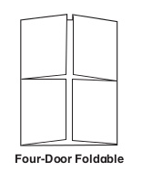
Four-Door Colonial Book

1. Choose one colony to research and illustrate.

2. Use notes, textbook, encyclopedia and computer to research for material and illustrations.

3. Project is due at the beginning of class on________________.

4. Cover of book should be completely covered with illustrations of the
region you choose to research.

5. Inside each door will be information of each colony within the
region.

6. Pick four of the topics to illustrate and write about.
Leaders of the colony or region (who, when, how).
Religion of the colony or region (describe).
Natural environment of the colony or region.
Natural resources of the colony or region.
Specific housing types of the colony or region.
Economics: how they made a living, profits, etc.
(shipbuilding, farming, industries, cash crops)
Slavery in the South

7. Look over rubrics to monitor your progress.

