5th Grade – Unit 4:
Suggested Scope and Sequence
Essential Questions:
How are fictional characters and real people changed through conflict?
How does point of view influence your opinion?

*The first four weeks of this unit focuses on slavery. The second four weeks focuses more on the Civil War. You may choose to do the latter four weeks first.

Week | Focus Standard | Vocabulary Addressed | Resources | Suggested Activities
Week 1  Launch: Slavery  Goal: I can determine the theme of a story and support my thinking with how characters respond to challenges and conflict.  Goal: I can use information from digital sources to locate an answer a question.  Guiding Questions:  What is conflict?  What is slavery? | RL.5.2 Determine a theme of a story, drama, or poem from details in the text, including how characters in a story or drama respond to challenges or how the speaker in a poem reflects upon a topic; summarize the text.  RL.5.7 Analyze how visual and multimedia elements contribute to the meaning, tone, or beauty of a text (e.g.,  graphic novel, multimedia presentation of fiction, folktale, myth, poem)  SL.5.2 Summarize a written text read aloud or information presented in diverse media and formats, including  visually, quantitatively, and orally  RI.5.7 Draw on information from multiple print or digital sources, demonstrating the ability to locate an answer to a question quickly or to solve a problem efficiently.  RI.5.8 Explain how an author uses reasons and evidence to support particular points in a text, identifying  which reasons and evidence support which point(s).  W.5.3 Write narratives to develop real or imagined experiences or events using effective technique, descriptive details, and clear event sequences. (Write a journal entry) | slavery  From 2nd Grade  conflict | - History Channel video clips (RI.5.3/RI.5.7)  Introduction & page 8  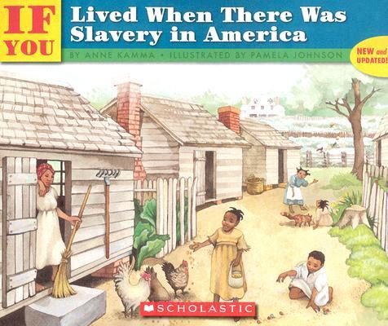  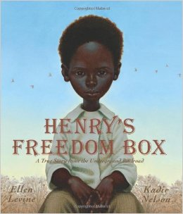  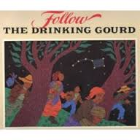  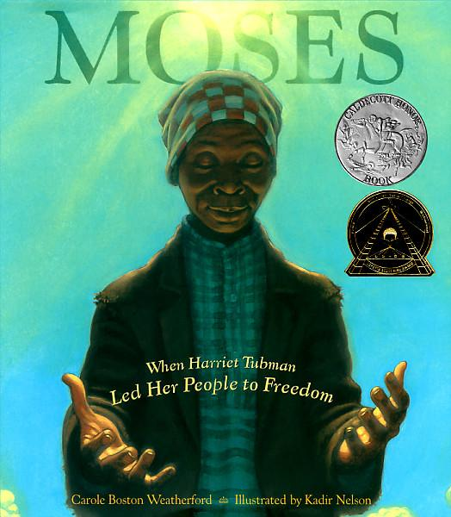 | - Listen to Follow the Drinking Gourd at http://www.youtube.com/watch?v=M1k4Qdq8juw  - Read Moses and/or Henry’s Freedom Box (RL.5.2/RL.5.7) *Borrow from your 2nd grade friends.  - Watch video clips and summarize information presented. (SL.5.2 & RI.5.8) *notetaking & stated opinions  - Read introduction and page 8 of If You Lived When There Was Slavery in America (RI.5.2 & RI.5.7)  - Students write a journal entry (clear event sequences and descriptive detail) from their perspective and from the perspective of a slave

Week | Focus Standard | Vocabulary Addressed | District Resources | Suggested Activities
Week 2  Goal: I can identify the opinion statement of an author and how he or she supports it.  Goal: I can compare the differing opinions of authors.  Goal: I can write an informational essay comparing opinions of authors.  Guiding Questions:  What is an opinion?  How do authors state their opinions?  How do authors support their opinions? | RI.5.6 Analyze multiple accounts of the same event or topic, noting important similarities and differences in the point of view they represent.  RI.5.8 Explain how an author uses reasons and evidence to support particular points in a text, identifying  which reasons and evidence support which point(s).  W.5.8 Recall relevant information from experiences or gather relevant information from print and digital  sources; summarize or paraphrase information in notes and finished work, and provide a list of sources.  RI.5.9 Integrate information from several texts on the same topic in order to write or speak about the subject  knowledgeably.  W.5.9 Draw evidence from literary or informational texts to support analysis, reflection, and research.  b. Apply grade 5 Reading standards to informational texts (e.g., “Explain how an author uses reasons and  evidence to support particular points in a text, identifying which reasons and evidence support which point[s]).  L.5.1 Demonstrate command of the conventions of standard English grammar and usage when writing or speaking.  a. Explain the function of conjunctions, prepositions, and interjections in general and  their function in particular sentences.  b. Form and use the perfect (e.g., I had walked; I have walked; I will have walked) verb tenses.  L.5.2 Demonstrate command of the conventions of standard English capitalization, punctuation, and spelling when writing.  d. Use underlining, quotation marks, or italics to indicate titles of works. |  | 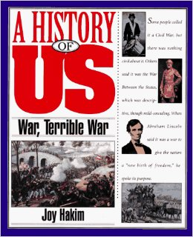  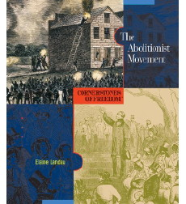  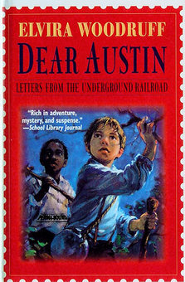  Pages 27-28 (RI.5.8)  “That’s how terrible slavery was.”  RI.5.6 Compare points of view by  analyzing pieces about John Brown | - Begin Dear Austin read aloud  - Students read pages 27-28 of If You Lived When There Was Slavery in America. ID opinion statement and how the author supports that statement. (RI.5.8)  - Watch video about John Brown http://www.youtube.com/watch?v=Ax7KjLUOt8w (SL.5.2 & RI.5.8)  - Students read pages 33-35 of Abolitionist Movement (RI.5.8/1 day) and read pages 54-top of 57 of War, Terrible War (RI.5.8/day 2).  - Students compare the differing opinions of the authors (RI.5.6/RI.5.8)  - Write an informational essay using information from the 2 articles about John Brown (RI.5.9 & W.5.9), “Compare how John Brown is portrayed in the Abolitionist Movement and in the War,Terrible War. Support your essay with information from both sources.”

Week | Focus Standard | Vocabulary Addressed | District Resources | Suggested Activities
Week 3  Goal: I can write an opinion with supporting evidence.  Goal: I can determine the theme of a story and support my thinking with how characters respond to challenges and conflict.  Goal: I can explain how chapters provide the overall structure of a text.  Guiding Questions:  What is opinion writing?  How does understanding the structure of a text help me? | RL.5.2 Determine a theme of a story, drama, or poem from details in the text, including how characters in a  story or drama respond to challenges or how the speaker in a poem reflects upon a topic; summarize the text.  RL.5.5 Explain how a series of chapters, scenes, or stanzas fits together to provide the overall structure of a  particular story, drama, or poem  RL.5.6 Describe how a narrator’s or speaker’s point of view influences how events are described.  W.5.1 Write opinion pieces on topics or texts, supporting a point of view with reasons and information.  a. Introduce a topic or text clearly, state an opinion, and create an organizational structure in which ideas are logically grouped to support the writer’s purpose.  b. Provide logically ordered reasons that are supported by facts and details.  c. Link opinion and reasons using words, phrases, and clauses (e.g., consequently, specifically).  d. Provide a concluding statement or section related to the opinion presented.  W.5.4 Produce clear and coherent writing in which the development and organization are appropriate to task, purpose, and audience. |  | Opinion Mentor Texts | - Continue reading Dear Austin  - Introduce Opinion Writing by looking at the standard with students and analyzing writing(day1)  - Analyze a good opinion piece, relating back to the standard (day 2)  - Interactive Writing on a topic- slavery(creating an opinion together- day 3)  - Students write an opinion: Was John Brown a good man?

Week | Focus Standard | Vocabulary Addressed | District Resources | Suggested Activities
Week 4  Goal: I can write a well constructed opinion.  Goal: I can use support from peers to strengthen my writing (revision).  Goal: I can use details in a text to compare characters.  Goal: I can describe how a character’s (Levi) point of view influences how events are described.  Guiding Questions:  How does working with a writing partner help me improve my writing?  How does point of view influence how events are described? | RL.5.2 Determine a theme of a story, drama, or poem from details in the text, including how characters in a  story or drama respond to challenges or how the speaker in a poem reflects upon a topic; summarize the text  RL.5.3 Compare and contrast two or more characters, settings, or events in a story or drama, drawing on specific details in the text (e.g., how characters interact).  RL.5.6 Describe how a narrator’s or speaker’s point of view influences how events are described.  W.5.5 With guidance and support from peers and adults, develop and strengthen writing as needed by planning, revising, editing, rewriting, or trying a new approach.  W.5.3 Write narratives to develop real or imagined experiences or events using effective technique, descriptive details, and clear event sequences. |  |  | - Continue practicing opinion writing on other topics and texts.  - Students finish reading Dear Austin, focusing on portions of the text  - Other options for Writing: write a letter from a character’s perspective, finish the story, or write an opinion about how the author ended the story.  - Summative Assessment RI.5.8 or W.1.3 from Teacher’s College Reading & Writing Project.

Week | Focus Standard | Vocabulary Addressed | District Resources | Suggested Activities
Week 5  Launch- Civil War  Goal:. I can explain the relationships or of events in the Civil War.  Goal: I can identify text structures (chronology, comparison, cause/effect,problem  /solution) in informational texts.  Goal: I can compare the structure of events in two texts.  Guiding Questions:  What is conflict?  What was the conflict that caused the Civil War? | RI.5.3 Explain the relationships or interactions between two or more individuals, events, ideas, or concepts in  a historical, scientific, or technical text based on specific information in the text  RI.5.4 Determine the meaning of general academic and domain-specific words and phrases in a text relevant  to a grade 5 topic or subject area.  RI.5.5 Compare and contrast the overall structure (e.g., chronology, comparison, cause/effect,problem/solution) of events, ideas, concepts, or information in two or more texts.  RI.5.7 Draw on information from multiple print or digital sources, demonstrating the ability to locate an  answer to a question quickly or to solve a problem efficiently.  W.5.3 Write narratives to develop real or imagined experiences or events using effective technique, descriptive details, and clear event sequences. | 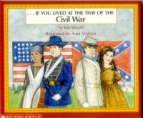 | - History Channel video clips (RI.5.3/RI.5.7)  - Civil War Discovery Box (W.5.8) from Shiloh Museum in Springdale OR field trip to Shiloh Museum (SL. 5.3)  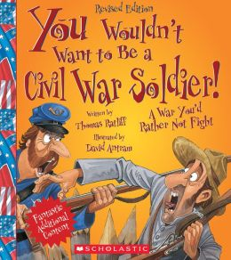 | - Look at map of states during Civil War (RI.5.7) Pg. 15 in If You Lived During the Time of the Civil War  - Students identify different types of text structure (RI.5.5)  - Students revise, edit, and publish on computer (W.5.5 & W.5.6) with writing from previous week.  - Students read letters, and identify features of a good letter. (W.5.3)  - Interactive Writing with a letter (write a letter with students)

Week | Focus Standard | Vocabulary Addressed | District Resources | Suggested Activities
Week 6  Goal: I can explain how the chapters in Bull Run fit together to provide different points of view.  Goal: I can write an imagined experience.  Guiding Questions:  How does understanding the structure of a text help me understand what I’m reading? | RL.5.5 Explain how a series of chapters, scenes, or stanzas fits together to provide the overall structure of a particular story, drama, or poem.  RL.5.6 Describe how a narrator’s or speaker’s point of view influences how events are described.  RL.5.2 Determine a theme of a story, drama, or poem from details in the text, including how characters in a story or drama respond to challenges or how the speaker in a poem reflects upon a topic; summarize the text.  W.5.3 Write narratives to develop real or imagined experiences or events using effective technique, descriptive details, and clear event sequences. |  | 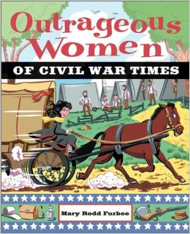  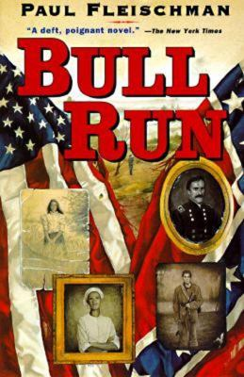 | - Discuss structure of text, why it may be difficult to read. RL.5.5  - Students take notes on each character as they read Bull Run (see graphic organizer on TCR) RL.5.6  - Students choose a character from Bull Run and write a letter or journal entry from that point of view, focusing on clear event sequences and descriptive detail W.5.3

Week | Focus Standard | Vocabulary Addressed | District Resources | Suggested Activities
Week 7  Goal: I can summarize a text, including the theme and details from the text.  I can compare characters in a story, using specific details in the text.  I can describe how a character’s point of view influences how an event is described.  Guiding Questions:  How does a character’s point of view influence how an event is described? | RL.5.2 Determine a theme of a story, drama, or poem from details in the text, including how characters in a story or drama respond to challenges or how the speaker in a poem reflects upon a topic; summarize the text.  RL.5.3 Compare and contrast two or more characters, settings, or events in a story or drama, drawing on  specific details in the text (e.g., how characters interact)  RL.5.6 Describe how a narrator’s or speaker’s point of view influences how events are described.  W.5.6 With some guidance and support from adults, use technology, including the Internet, to produce and  publish writing as well as to interact and collaborate with others; demonstrate sufficient command of  keyboarding skills to type a minimum of two pages in a single sitting. |  |  | - Students choose 2 characters from Bull Run to compare, using evidence such as how characters interact, how they respond to challenges, as well as their thoughts, feelings, and actions, and/or traits. Students record information on matrix or other note-taking sheet, then use that information to write an informational comparison essay (connect back to text structures from week 5- what does a comparison text structure look like?)  - Students compose comparison essay on laptop or in computer lab if possible (W.5.6 says they should be able to type 2 pages in a single sitting)

Week | Focus Standard | Vocabulary Addressed | District Resources | Suggested Activities
Week 8  Goal:  I can produce writing that shows evidence of planning, organization, & development.  I can create a multimedia presentation that uses technology, including audio, and provides evidence of my new learning.  I can effectively present my multimedia presentation orally, speaking clearly and at an understandable pace.  Guiding Questions: | RL.5.6 Describe how a narrator’s or speaker’s point of view influences how events are described.  W.5.4 Produce clear and coherent writing in which the development and organization are appropriate to task, purpose, and audience.  W.5.5 With guidance and support from peers and adults, develop and strengthen writing as needed by planning, revising, editing, rewriting, or trying a new approach.  W.5.6 With some guidance and support from adults, use technology, including the Internet, to produce and publish writing as well as to interact and collaborate with others; demonstrate sufficient command of keyboarding skills to type a minimum of two pages in a single sitting.  SL.5.4 Report on a topic or text or present an opinion, sequencing ideas logically and using appropriate facts and relevant, descriptive details to support main ideas or themes; speak clearly at an understandable pace.  SL.5.5 Include multimedia components (e.g., graphics, sound) and visual displays in presentations when appropriate to enhance the development of main ideas or themes.  SL.5. 6 Adapt speech to a variety of contexts and tasks, using formal English when appropriate to task and situation. |  |  | - Students choose one piece of writing and create a multimedia presentation that includes audio  -Present to the class  *Summative Assessment (RL.5.6, W.5.3, RL.5.3)

