A poem by Joseph Bruchac

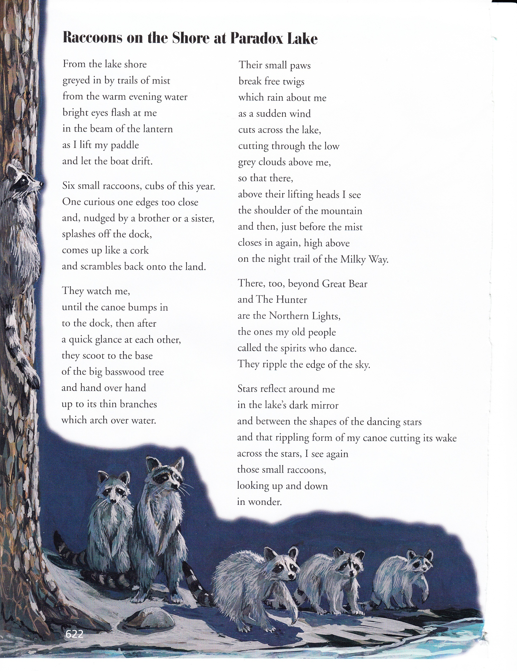

**In .**

In this poem, a person encounters some raccoons. Think about how the author describes the raccoons.

Write an original story describing the same experience from one of the raccoon’s point of view.

________________________________________________________________________________________________________________________________________________________________________________________________________________________________________________________________________________________________________________________________________________________________________________________________________________________________________________________________________________________________________________________________________________________________________________________________________________________________________________________________________________

_____________________________________________________________________________________________________________________________________________________________________________________________________________________________________________________________________________________________________________________________________________________________________________________________________________________________________________________________________________________________________________________________________________________________________________________________________________________________________________________________________________________________________________________________________________________________________________________________________________________________________________________________________________________________