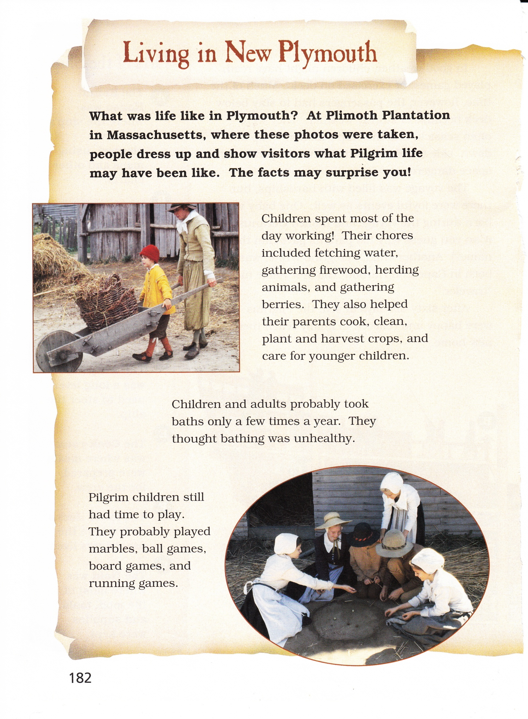

What does the word “chores” mean as it is used in the passage?

Which phrases from the passage best help the reader understand the meaning?

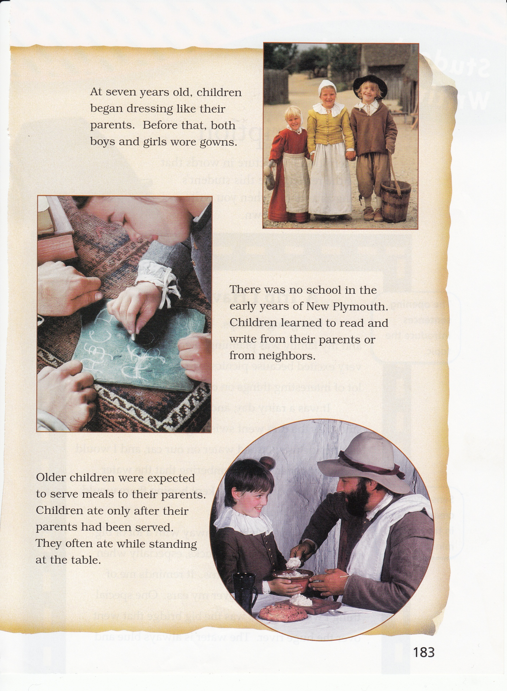

Based on the passage, how do the children feel about their parents?

Which sentences from the passage best show how the children feel?

.

In this passage, the author describes daily life at Plimoth Plantation. Think about the details the author used to tell about the lives of children in this time period.

Write a diary entry where you are a child at Plimoth Plantation describing one day of your life. In your entry, be sure to use what you have learned from “Living in New Plymouth” as you tell about your day.

________________________________________________________________________________________________________________________________________________________________________________________________________________________________________________________________________________________________________________________________________________________________________________________________________________________________________________________________________________________________________________________________________________________________________________________________________________________________________________________________________________

_____________________________________________________________________________________________________________________________________________________________________________________________________________________________________________________________________________________________________________________________________________________________________________________________________________________________________________________________________________________________________________________________________________________________________________________________________________________________________________________________________________________________________________________________________________________________________________________________________________________________________________________________________________________________