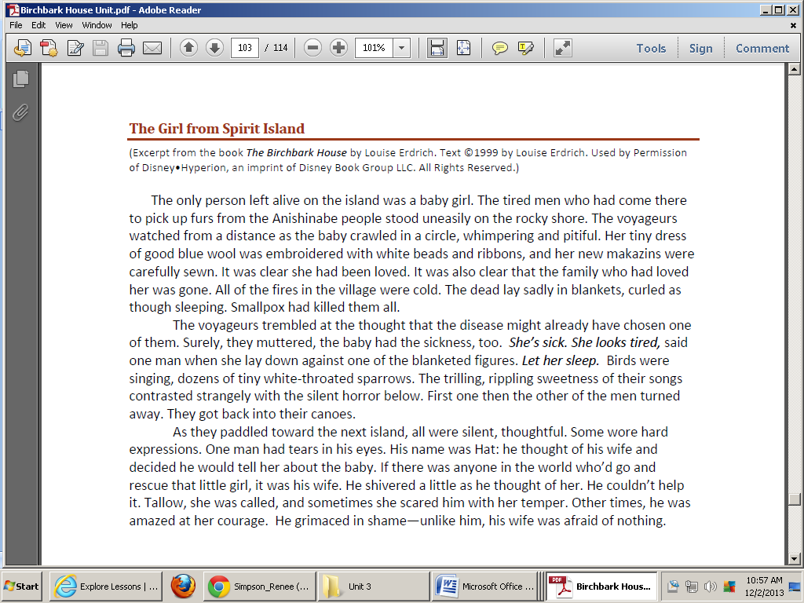



TEACHER NOTES

* First read- blue questions (key ideas and details)
* Second read- orange questions (craft and structure)
* Third read (if necessary)- purple questions (integration of knowledge and ideas)

Why does the author type certain words in italics in paragraph 2? (character speaking) How is this typically marked in text? (set apart with comma and quotation marks)

How did they know that the baby’s family was gone? (“The dead lay sadly in blankets…)

The passage refers to the men as “voyageurs.” What does this word mean? What words or phrases support your response? (travelers; canoe, come to *pick up* furs-not from that place. Students could also talk about the word “voyage” and its meaning.)

What two things did the voyageurs know instantly about the baby on the rocky shore?

(“…she had been loved.” “…family was gone.”

What are the “figures” mentioned in paragraph 2? Why did the author use this word? (figures are bodies “…in blankets…” This word paints a clear picture of what they look like-not like people any more…just mounds on the dirt… lifeless.)

Why did Hat shiver when he thought of Tallow? (“…she scared him with her temper.”

Why did the men come to the island? Why would they want furs? How does this relate to the pioneers that we studied in The Pioneer Sampler? (sell or trade for furs…peddlers…etc.)

What is the “silent horror” the author is talking about in paragraph 2? Why is this “contrasted strangely” with what is happening in the air? (birds are happy but all of the people are dead)

Why were the men silent as they paddled toward the next island? How were they feeling? (ashamed, afraid, embarrassed, weak)

What were they afraid of? (catching Smallpox)