Excerpt from “Leonardo the Artist and Dreamer”

Hands On History: Leonardo da Vinci

Leonardo is one of the world’s most famous artists, and his paintings are the most studied and analyzed in the history of art, even though only a few of his works survive.

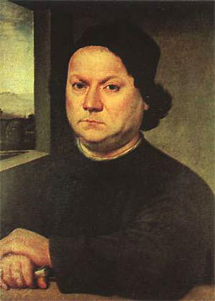Leonardo began drawing when he was a child growing up in Florence and showed talent early. In fact, his father was so impressed with Leonardo’s drawing ability that when Leonardo was in his early teens, his father brought some of Leonardo’s drawings to the well-known artist Andrea del Verrocchio. Verrocchio must have been impressed, because he invited Leonardo to become an apprentice in his *botte*ga, or artists’ studio.

During the Renaissance, being an artist was a trade, similar to being a blacksmith, weaver, or other craftsperson. Unlike today’s artists, who usually create a work of art by themselves from start to finish and who usually specialize in just one medium, such as painting or sculpture, artists in the Renaissance worked together on projects, with different artists working on different parts of a project at any given time. Artists often worked equally well in many different media. For example, if Verrocchio were offered a job to paint a portrait for a church, several of the artists in his studio would work on parts of the painting. If he received a commission to create a sculpture, the same artists might work together on that.

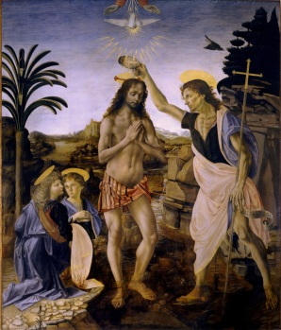 One of the earliest examples of Leonardo’s work, in fact, is in a painting called *The Baptism of Christ*, that was created in Verrocchio’s studio. Leonardo painted one of the angels, as well as the background of the painting, and the story goes that when Verrocchio saw Leonardo’s work, he was so overcome by his pupil’s talent that he decided to stop painting. The story probably isn’t true, but it suggests how unusually talented Leonardo was as an artist.

Leonardo spent much of his time drawing. He carried a notebook with him at all times, tied to a thong around his waist, and he would often stop to sketch what he saw around him, whether it was a group of old men laughing in a town square or a flock of swallows in flight. This practice made him very aware of how people and animals moved, and he captured this movement in his paintings. He was the first to study the physical proportions of people, and he used this knowledge to create accurately proportioned figures in his paintings.

**1** In paragraph 2, why does the author put the word *bottega* in italics?

______________________________________________________________________________

**2** What does medium mean as it is used in paragraph 3? Explain you thinking with evidence from the text.

____________________________________________________________________________________________________________________________________________________________

**3** What does the word commission mean as it is used in paragraph 3? Explain you thinking with evidence from the text.

____________________________________________________________________________________________________________________________________________________________

**4** Think about the clothes and accessories we wear today. In the following line from paragraph 5, what word could you use in place of the underlined word? Explain your inference with evidence from the text.

“He carried a notebook with him at all times, tied to a thong around his waist…”

____________________________________________________________________________________________________________________________________________________________

____________________________________________________________________________________________________________________________________________________________