5th Grade – Unit 2: What a Character!
Suggested Scope and Sequence – Option 1
Week | Focus Standard | Vocabulary Addressed | District Resources | Suggested Activities
Week 1  Goal: I can describe a character in depth drawing on specific details from the text.  Guiding Questions:  How do authors effectively develop characters in a text? | RL.5.1 Quote accurately from a text when explaining what the text says explicitly and when drawing inferences from the text.  RL.5.3 Compare and contrast two or more characters, drawing on specific details in the text (e.g., how characters interact).  L.5.1 Demonstrate command of the conventions of standard English grammar and usage when writing or speaking. | Characters:  - Character traits  - Actions  - Dialogue  RL.5.1 – Notating inferences  - Quotes  - Inferences | 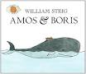  Amos and Boris by William Steig  (from 3rd grade, Unit 2)  Tacky the Penguin by Helen Lester  (from 4th grade, Unit 1)  Class set  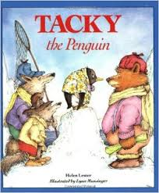  *Additional titles – see text list | - Review the fourth grade standard RL.4.3.: Inferring character traits based on a character’s thoughts, words, or actions.  - Notice character traits in short stories.  - Learn how to properly notate evidence for character traits using quotations – use the “What a Charcter” graphic organizer to record evidence that supports chosen character traits
Week | Focus Standard | Vocabulary Addressed | District Resources | Suggested Activities
Week 2  Goal: I can identify how characters in a story respond to challenges.  Guiding Questions:  How do authors effectively develop characters in a text? | RL.5.1 Quote accurately from a text when explaining what the text says explicitly and when drawing inferences from the text.  RL.5.2 Determine…how characters in a story or drama respond to challenges; summarize the text (introduce)  RL.5.3 Compare and contrast two or more characters, drawing on specific details in the text (e.g., how characters interact).  L.5.1 Demonstrate command of the conventions of standard English grammar and usage when writing or speaking | - Challenges  - Character change  - Summarize | 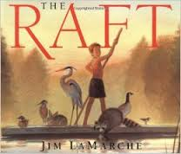  The Raft by Jim LaMarche  (from 3rd grade, Unit 2)  The Memory Sting by Eve Bunting (from 3rd grade, Unit 1)  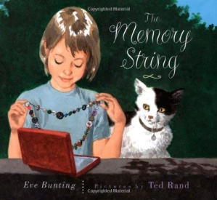  *Additional titles – see text list | - Read texts to notice how characters respond to challenges  - Chart how characters change from the beginning of the story to the end of the story  - Teach/review summarization skills  - Continue to notice character traits with evidence from the texts and add to the “What a Character” graphic organizer
Week | Focus Standard | Vocabulary Addressed | District Resources | Suggested Activities
Week 3  Goal: I can identify how characters respond to challenges.  Guiding Questions:  How do authors effectively develop characters in a text? | RL.5.1 Quote accurately from a text when explaining what the text says explicitly and when drawing inferences from the text.  RL.5.2 Determine…how characters in a story or drama respond to challenges; summarize the text (introduce)  RL.5.3 Compare and contrast two or more characters, drawing on specific details in the text (e.g., how characters interact).  L.5.1 Demonstrate command of the conventions of standard English grammar and usage when writing or speaking  L.5.2a Use punctuation to separate items in a series. | - Conflict  - Character vs. character  - Character vs. self  - Character vs. nature  - Character vs. society | Character vs. Character  The Three Little Wolves and the Big Bad Pig by Eugene Trivizas (from Kindergarten, Unit 2)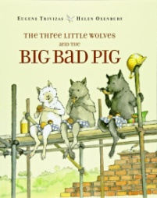  Character vs. Self  Koala Lou by Mem Fox (from Kindergarten, Unit 5)  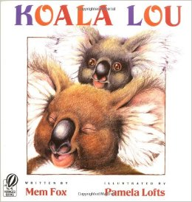  *Additional titles – see text list | - Provide xplicit instruction on various types of conflict  - Provide opportunities for students to identify types of conflict (challenges) that characters face in stories  - Notice and discuss how character conflict causes characters to change throughout a story  - Continue adding to the “What a Character” chart  - Compare and Contrast characters: Consider their unique traits, the ways each approaches the problems in their story, and if/how the characters each change at the end of their story.

Week | Focus Standard | Vocabulary Addressed | District Resources | Suggested Activities
Week 4  Goal: I can compare and contrast two or more characters.  Goal: I can identify how characters respond to challenges.  Guiding Questions:  How do authors effectively develop characters in a text? | RL.5.1 Quote accurately from a text when explaining what the text says explicitly and when drawing inferences from the text.  RL.5.2 Determine…how characters in a story or drama respond to challenges; summarize the text (introduce)  RL.5.3 Compare and contrast two or more characters, drawing on specific details in the text (e.g., how characters interact).  L.5.1 Demonstrate command of the conventions of standard English grammar and usage when writing or speaking  L.5.2a Use punctuation to separate items in a series. | No new vocabulary addressed | The Apprentice by Pilar Molina Llorente (from 5th grade, Unit 2) – class set  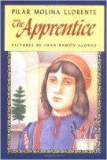 | - Read The Apprentice and apply previous learning ( identifying character traits, comparing and contrasting characters, identifying how characters respond to challenges, and identifying how characters develop throughout the course of a story).  - Begin a new “what a character” chart or similar organizer for students to take notes
Week | Focus Standard | Vocabulary Addressed | District Resources | Suggested Activities
Week 5  Goal: I can determine the theme of a story.  Guiding Questions:  How do authors use characters to develop a theme? | RL.5.1  RL.5.2 Determine a theme of a story from details in the text including how characters in a story or drama respond to challenges summarize the text (introduction this unit).  RL.5.3  L.5.1  L.5.2a | - Theme | The Apprentice by Pilar Molina Llorente (from 5th grade, Unit 2) – class set  *Previously read texts | - Continue previous week’s learning goals  - Explicitly teach students about theme  - Revisit previously read texts from Unit 1 & 2 to identify the themes of the stories  - Identify the theme of The Apprentice
Week | Focus Standard | Vocabulary Addressed | District Resources | Suggested Activities
Week 6  Goal: I can identify the main idea in a text and explain how they are supported by key details.  Goal: I can summarize the text.  Guiding Questions: | RI.5.1 Quote accurately from a text when explaining what the text says explicitly and when drawing inferences from the text.  RI.5.2 Determine two or more main ideas of a text and explain how they are supported by key details: summarize the text.  W.5.8 Recall relevant information from experiences or gather relevant information from print and digital sources; summarize or paraphrase information in notes and finished work and provide a list of sources (list one source this unit).  W.5.9 Draw evidence from literary or information text to support analysis, reflection, and research.  L.5.1 Demonstrate command of the conventions of standard English grammar and usage when writing or speaking | - Main idea  - Key details  - Relevant information  - Print and digital sources  - Citations | 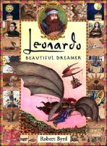  Leonardo, Beautiful Dreamer, “The Dining Hall of the Monks” by Robert Byrd (from 5th grade, Unit 2)  “The Last Supper” painting  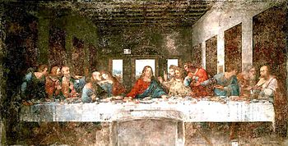  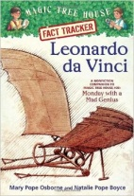  Fast Tracker: Leonardo da Vinci by Mary Pope Osborne and Natalie Pope Boyce (from 5th grade, Unit 2)  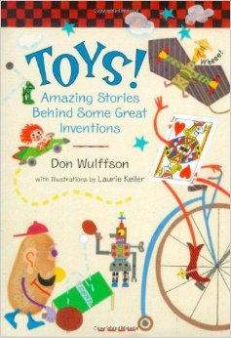  Toys – Amazing Stories Behind Some Great Inventions by Don Wulffson (from 5th grade, Unit 2) | - Compare and contrast the themes of the artwork from “The Last Supper” with “The Dining Hall of the Monks”  Nonfiction: Serves as an introduction to nonfiction and research for later units  - Explicitly teach main idea and key details  - Explicitly teach students how to take notes/organize information by main ideas/key details  - Model and practice summarizing nonfiction texts using the main idea and key details  - With modeling and scaffolding, allow students to take notes and summarize the main idea/key details of one section of the Fast Tracker book (in groups).  - Allow groups to present their findings from various chapters.  - Practice citing sources in research
5th Grade – Unit 2: What a Character!
Suggested Scope and Sequence – Option 2
*If Option 2 is chosen, the content being taught each week will be the same:
- Week 1 – Character Traits
- Week 2 – Character Change
- Week 3 – Character Conflicts
- Week 4 – Comparing and Contrasting content from weeks 1-3
- Week 5 – Theme
- Week 6 – Nonfiction focus (this week is completely the same for either option)

However, The Apprentice will be read beginning in Week 1. New content will be introduced at the beginning of the week using the short texts that have been included. However, the rest of the week (Days 2-5) will be spent applying the new content learned in The Apprentice.
- Week 1 –
- Day 1 – explicitly teach character traits and how to notate evidence that supports chosen character traits; practice learning using a short story/storybook
- Days 2-5 – apply learning while reading The Apprentice
- Week 2 –
- Day 1 – explicitly teach character change and how to summarize a text; practice identifying character change and summarizing a text using a short story/storybook
- Days 2-5 – apply learning while reading The Apprentice
- Week 3 –
- Day 1 – explicitly teach types of conflict; practice identifying conflict and how it causes characters to change using a short story/storybook
- Days 2-5 – apply learning while reading The Apprentice
- Week 4 –
- Days 1-5: Continue reading The Apprentice. Practice identifying character traits, comparing and contrasting characters, identifying how characters respond to challenges, and identifying how characters develop throughout the course of a story.
- Week 5 –
- Day 1 – Explicitly teach theme. Practice identifying theme in previously read texts.
- Days 2-5 – Continue reading The Apprentice. Identify the theme(s) found in The Apprentice.
- Week 6 – Nonfiction focus – This week is completely the same for either option.

