The Renaissance was a cultural and scholarly movement which stressed the rediscovery and application of texts and thought from classical antiquity, occurring in Europe c. 1400 – c. 1600.
At its core, the Renaissance was a movement dedicated to the rediscovery and use of classical learning, that is to say knowledge and attitudes from the Ancient Greek and Roman eras. Renaissance literally means ‘rebirth’, and Renaissance thinkers believed the period between themselves and the fall of Rome, which they labeled the Middle Ages, had seen a decline in cultural achievement compared with the earlier eras. Participants intended, through the study of classical texts, textual criticism and classical techniques, to both reintroduce the heights of those ancient days and improve the situation of their contemporaries. Some of these classical texts survived only amongst Islamic scholars and were brought back into Europe at this time.
“Renaissance” can also refer to the period, c. 1400 – c. 1600. The era was dynamic, with European explorers “finding” new continents, the transformation of trading methods and patterns, the decline of feudalism, scientific developments such as the Copernican system of the cosmos and the rise of gunpowder. Many of these changes were triggered, in part, by the Renaissance, such as classical mathematics stimulating new financial trading mechanisms, or new techniques from the east boosting ocean navigation. The printing press was also developed, allowing Renaissance texts to be disseminated widely.
Classical culture had never totally vanished from Europe, and it experienced sporadic rebirths. There was the Carolingian Renaissance in the eighth to ninth centuries and a major one in the “Twelfth Century Renaissance”, which saw Greek science and philosophy returned to European consciousness and the development of a new way of thinking which mixed science and logic called Scholasticism. What was different in the fifteenth and sixteenth centuries was that this particular rebirth joined together both the elements of scholarly enquiry and cultural endeavor with social and political motivations to create a much broader movement.
Across the fourteenth century, and perhaps before, the old social and political structures of the medieval period broke down, allowing new concepts to rise. A new elite emerged, with new models of thought and ideas to justify themselves; what they found in classical antiquity was something to use both as a prop and a tool for their aggrandizement. Exiting elites matched them to keep pace, as did the Catholic Church. Italy, from which the Renaissance evolved, was a series of city states, each competing with the others for civic pride, trade and wealth. They were largely autonomous, with a high proportion of merchants and artisans thanks to the Mediterranean trade routes.
At the very top of Italian society, the rulers of the key courts in Italy were all “new men”, recently confirmed in their positions of power and with newly gained wealth, and they were keen to demonstrate both. There was also wealth and the desire to show it below them. The Black Death had killed millions in Europe and left the survivors with proportionally greater wealth, whether through fewer people inheriting more or simply from the increased wages they could demand. Italian society, and the results of the Black Death, allowed for much greater social mobility, a constant flow of people keen to demonstrate their wealth. Displaying wealth and using culture to reinforce your social and political was an important aspect of life in that period, and when artistic and scholarly movements turned back to the classical world at the start of the fifteenth century there were plenty of patrons ready to support them in these endeavors to make political points.
For information on the causes, go to http://europeanhistory.about.com/od/therenaissance/a/causesrenaissance.htm.
Information from www.europeanhistory.about.com.
Essential Question(s) How does creativity change the world? How is necessity the mother of invention?
Standards and Objectives
5.RL.1 Quote accurately from a text when explaining what the text says explicitly and when drawing inferences from the text.
I can quote accurately from text.
I can quote accurately from text to support my inferences.
I can quote accurately from text to support inferences and analyze a text.
5.RL.9 Compare and contrast stories in the same genre (e.g., mysteries and adventure stories) on their approaches to similar themes and topics.
I can compare and contrast stories in the same genre.
5.RL.2 Determine a theme of a story, drama, or poem from details in the text, including how characters in a story or drama respond to challenges or how the speaker in a poem reflects upon a topic; summarize the text.
I can determine a theme of a story from details in the text, including how characters respond to a challenge.
5.RL.3 Compare and contrast two or more characters, settings, or events in a story or drama, drawing on specific details in the text (e.g., how characters interact).
I can compare and contrast two or more characters in a story, using specific details from the text.
I can explain the relationships between two or more events, ideas, or concepts in a text based on specific information in a text.
5.RI.3 Explain the relationships or interactions between two or more individuals, events, ideas, or concepts in a historical, scientific, or technical text based on specific information in the text.
I can explain the relationships between two or more events, ideas, or concepts in a text based on specific information in a text.
5.RI.9 Quote accurately from a text when explaining what the text says explicitly and when drawing inferences from the text.
5.W.2 Write informative/explanatory texts to examine a topic and convey ideas and information clearly.
I can decide on a research topic using a criteria-based process.
I can integrate text from multiple sources in order to write about a subject knowledgably.
I can write an informative text to examine a topic and convey ideas and information clearly.
5.RI.9 Integrate information from several texts on the same topic in order to write or speak about the subject knowledgeably.
5.SL.1 Engage effectively in a range of collaborative discussions (one-on-one, in groups, and teacher led) with diverse partners on grade 5 topics and texts, building on others’ ideas and expressing their own clearly.
I can integrate text from multiple sources in order to write and speak about a subject knowledgably.
5.W.2a Introduce a topic clearly, provide a general observation and focus, and group related information logically; include formatting (e.g., headings), illustrations, and multimedia when useful to aiding comprehension.
5.W.2b Develop the topic with facts, definitions, concrete details, quotations, or other information and examples related to the topic.
Within the writing process, I can develop an I-Plan to organize my thoughts.
Within the writing process, I can develop a rough draft.
5.W.1c Link opinion and reasons using words, phrases, and clauses (e.g., consequently, specifically).
5.L.1b Form and use the perfect (e.g., I had walked; I have walked; I will have walked) verb tenses.
Within the writing process, I can revise my style.
5.L.2 Demonstrate command of the conventions of standard English capitalization, punctuation, and spelling when writing.
Within the writing process, I can edit the mechanics of my writing.

Connections | Art da Vinci (Mona Lisa), Michelangelo (Sistine Chapel), Michelangelo (Dome of St. Peter’s Basilica), Raphael (School of Athens), Donatello (St. George), Pieter Bruegel (Peasant Wedding), da Vinci (The Last Supper)  Music Traditional “Greensleeves,” Canadian Brass “English Renaissance Music,” The King’s Singers (Madrigals)  Technology da Vinci’s Notebook, Renaissance Research, Inventors, da Vinci/Michelangelo Webquest
Read Aloud The Apprentice
Teaching Text(s) Leonardo Beautiful Dreamer, Toys!
Student Texts Historical fiction of choice
 | Tier II Vocabulary bibliography character development fiction nonfiction paraphrase primary source documents
Science Inventors through various time periods
Social Studies The Renaissance; the Reformation

Goal: Goal Setting APK: Access Prior Knowledge N: New Information a: Application Goal: Generalize Goal
*Speaking and Listening Standards embedded in classroom discussions or part of application step*
 | Reading | Writing | Word Study
 | Whole Group 15-20 minutes  Read Aloud/Application 30 minutes | Whole Group 15-20 minute  Application/Conferencing 30 minutes  Sharing 10 minutes | Vocabulary, Language  Standards, and Spelling  10 minutes
Lesson 1 – Introduction to Unit | 1st hour  Goal: I can read and research information about the Renaissance so that I can discuss and write about it.  * The Renaissance time period  * Inventions  APK: Short video on time period to show images of time period  N: Mini-lecture (notes) using website for information (http://www.learner.org/interactives/renaissance/index.html)  a: T-chart modeled after website and discussion about themes of Renaissance – include word study  Goal: Review the goal  2nd hour:  Goal: I know about Renaissance Thinking and can use it to generate new ideas and products.  * the process of inventing  APK: Invent something using four straws, four marshmallows, four LifeSavers, a pair of scissors, a sheet of paper, and 3 small pieces of duct tape.  N: Teach concept “Renaissance Thinking” tied to the essential question – How does creativity change the world?  THINKING anagram: T – Turning Point, H- Heightened Curiosity, I – Invention, N – New Forms, K – Knowledge of Reading and Writing  a: Read from Science book and apply anagram. (Gun powder or printing press).  Goal: Reflection writing | Note taking throughout using T-chart and conventions  Reflection writing | Frayer Model – “invent”  definition  characteristics  example  non-example  word  Add word to word wall and notebook
Lesson 2 | Goal: I can quote accurately from text. 5.RL.1/5.RL.9  APK: Image on Organizing (Disney storyboard)  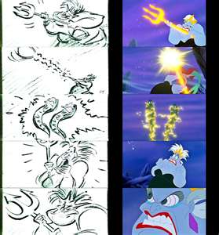  N: T-Chart formatting  Topic/Section or Chapter Response and Text  Chapter # Main Idea  a: Take notes about main idea using T-Chart with the Apprentice (Act. 1); create Act. 3 chart and complete about main character (as a class)  Independent Reading: Read a historical fiction in 4 weeks, in order to compare and contrast the genre by the end of the unit. Must keep T-Chart notes.  Goal: Discuss “What did you learn about taking notes?” | Goal: Within the writing process, I can develop an I-Plan to organize my thoughts. 5.W.2a, 5.W.2b  APK: Images of organized locker and unorganized locker  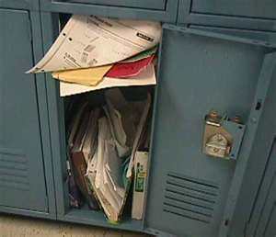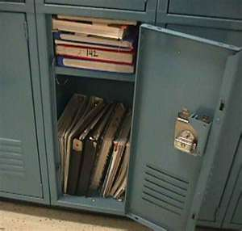  N: Read informative text. Locate the introduction, body paragraphs (topic sentence, detail sentences, conclusion sentence), conclusion paragraph. Discuss the function of each.  a: Place information into I-Plan.  Introduction  Topic 1  Topic 2  Topic 3  Opinion  Topic  Support  Support  Support  Conclude  Topic  Support  Support  Support  Conclude  Topic  Support  Support  Support  Conclude  Conclusion  Topic 1  Topic 2  Topic 3  Opinion  Goal: Discuss “Why is organizing your writing important?”
Lesson 3 | Goal: I can quote accurately from text. 5.RL.1/5.RL.9  APK: YouTube Video of boomerang accuracy (100% Accuracy: Seoul Boomerang Expert, Part 2)  N: Noting page number and quotation marks to quote text  Topic or Chapter Response and Text  Chapter # p. # “text” - response to text  a: Take notes about main idea using T-Chart with the Apprentice (Act. 1)  Independent Reading: Read a historical fiction in 4 weeks, in order to compare and contrast the genre by the end of the unit. Must keep T-Chart notes.  Goal: Discuss “How does the main idea help you as a reader?” | Goal: Within the writing process, I can develop an I-Plan to organize my thoughts. 5.W.2a, 5.W.2b  APK: Image of a pattern (same picture over and over like I-plan, but different colors like the different information/details in each text)  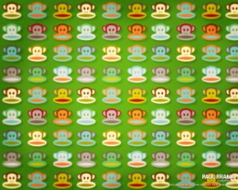  N: Read informative text. Locate the introduction, body paragraphs (topic sentence, detail sentences, conclusion sentence), conclusion paragraph. Discuss the function of each.  a: Place information into I-Plan.  Introduction  Topic 1  Topic 2  Topic 3  Opinion  Topic  Support  Support  Support  Conclude  Topic  Support  Support  Support  Conclude  Topic  Support  Support  Support  Conclude  Conclusion  Topic 1  Topic 2  Topic 3  Opinion  Goal:
Lesson 4 | Goal: I can quote accurately from text to support my inferences. 5.RL.1/5.RL.9  APK: Image of an optical illusion (See what’s there and what’s hidden)  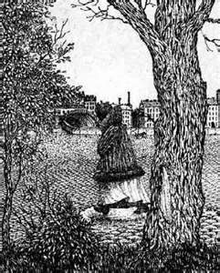  N: Define inferring (Deciding what is most likely true, based on the text; not directly stated in text;)  Inferring equation  Text + Schema = Inference  Thinking Skill: Inferring  1. What was my inference?  2. What information did I use to make the inference?  3. How good was my thinking?  4. Do I need to change my thinking?  (See Teaching Inference R. Marzano)  a: Make inferences and provide supporting evidence by quoting accurately from text using T-Chart with the Apprentice (Act. 1); Provide multiple examples;  Independent Reading: Read a historical fiction in 4 weeks, in order to compare and contrast the genre by the end of the unit. Must keep T-Chart notes.  Goal: Discuss “How would you define inferring in your own words?” | Goal: Within the writing process, I can develop an I-Plan to organize my thoughts. 5.W.2a, 5.W.2b  APK: Image of stoplight (when to go, slow down, and stop)  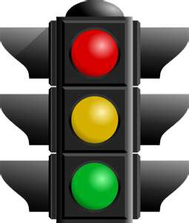  N: Prepare blank I-Plan (color code)  Introduction Green  Topic 1 Circle Topic 1  Topic 2 Circle Topic 2  Topic 3 Circle Topic 3  Opinion Underline  Topic Green  Support Yellow  Support Yellow  Support Yellow  Conclude Red  Topic Green  Support Yellow  Support Yellow  Support Yellow  Conclude Red  Topic Green  Support Yellow  Support Yellow  Support Yellow  Conclude Red  Conclusion Green  Topic 1 Circle Topic 1  Topic 2 Circle Topic 2  Topic 3 Circle Topic 3  Opinion Underline  a: Students color-code informational text, create I-Plan from informational text, and color-code I-Plan.  Goal: Discuss “What did you learn today about organizing your thoughts?”
Lesson 5 | Goal: I can quote accurately from text to support inferences. 5.RL.1/5.RL.9  APK: YouTube “Birth to 10 years” time lapse (compare change overtime physically to change personality/character)  N: Define character trait: describing a person’s emotions, attitude, or behavior  List words to describe a character and how the author builds a character;  Author’s clues Possible Descriptions  Character’s actions How a character reacts What the character says or thinks How the character says something Physical appearance Clothing Interests/Hobbies Where the character lives Bossy Brave Careless Cautious Creative Focused Friendly Funny Giving Hard- working Helpful Honest Impatient Lazy Loving Loyal Messy Obedient Polite Rude Selfish Shy Sneaky Spoiled Stubborn  Info from www.laurachandler.com  a: Create character chart and complete about main character (Act. 2); Make inferences (using thinking skill process) and provide supporting evidence by quoting accurately from text using T-Chart with the Apprentice (Act. 1);  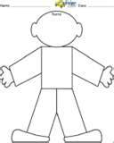  Independent Reading: Read a historical fiction in 4 weeks, in order to compare and contrast the genre by the end of the unit. Must keep T-Chart notes.  Goal: Discuss “What did you learn about inferring about characters today?” | Goal: Within the writing process, I can develop an I-Plan to organize my thoughts. 5.W.2a, 5.W.2b  APK: Rubik cube video (out of order vs. organized and in its place)  N: Teacher reads informational text in which sentences are out of order. Students receive a copy of the text, but the sentences are cut onto different strips of paper.  a: Students sort the sentences, write it in correct order, color-code text, create I-Plan from text, and color-code I-Plan.  Goal: Reflective writing “Why is text organization important for the reader? The writer?”
Lesson 6 | Goal: I can quote accurately from text to support inferences and analyze a text. 5.RL.1/5.RL.9  APK: Video of I Love Lucy chocolate line fiasco (speed changes, so outcome changes)  N: Thinking Skill: Systems Analysis  - I identify something as a system.  - I state all of the parts of the system and how they work.  - I change one part of the system to see what would happen.  - I make a conclusion about how the one change made the system change.  - I repeat the process.  a: Discuss and analyze a system in The Apprentice.  - I identify something as a system. (character in maestro’s house)  - I state all of the parts of the system and how they work. (apprentice, maestro, maid, boy in attic, other boys)  - I change one part of the system to see what would happen. (apprentice is forced to be there and doesn’t want to be a painter)  - I make a conclusion about how the one change made the system change. (apprentice tells police about boy in the attic)  - I repeat the process.  Take notes about inferences, main idea, and analysis using T-Chart with the Apprentice (Act. 1);  Independent Reading: Students are required to read a historical fiction in 4 weeks, in order to compare and contrast the genre by the end of the unit. Must keep T-Chart notes.  Goal: Discuss “What does it mean to analyze?” | Goal: Within the writing process, I can develop a rough draft. 5.W.2a, 5.W.2b  APK: YouTube “Escalator Failure” (writing is hard, but you have the tools you need)  N: Shared writing of I-Plan and rough draft.  * Develop topic with facts, concrete details, quotations and examples.  * Develop topic with focus  Introduction  Topic 1  Topic 2  Topic 3  Opinion  Topic  Support  Support  Support  Conclude  Topic  Support  Support  Support  Conclude  Topic  Support  Support  Support  Conclude  Conclusion  Topic 1  Topic 2  Topic 3  Opinion  a: Partner Writing: Create I-Plan and write rough draft. Color-code to self-evaluate format.  Goal: Reflective writing about “Why do we use the term ‘rough draft’?
Lesson 7 | Goal: I can determine a theme of a story from details in the text, including how characters respond to a challenge. 5.RL.2  APK: Movie trailer of “October Sky Official Trailer #1”; clips from movie to determine what the whole movie is about  N: List of literary themes and steps  Common Themes Definition/Steps  Change vs tradition Coming of age Death Discovery Family Fate and free will Fear of failure Good versus bad Greed Heroism Individuality Learn from mistake Love and sacrifice Man against nature Overcoming weakness/fear Persistence Power Racism Respect Self-preservation War Theme: view about life and how people behave. Steps 1. Analyze the main character 2. Identify the conflict 3. Know how the conflict is resolved 4. Understand what the main character learned 5. Generalize that lesson to apply to everyone  Guided Practice: Watch short YouTube videos and read books to determine theme with supporting evidence and using list of themes and steps: For the Birds (Individuality; Respect), Scrat’s Continental Crack-Up (Persistence), Uncle Jed’s Barbershop (Justice; Pursuing a Dream)  Aesop’s Fables: The Tortoise and the Hare, The Ants and the Grasshopper, The Lion and the Mouse  a: Determine theme of The Apprentice with supporting evidence from notes. (Act. 2)  Goal: Discuss “What did you learn about theme today?” | Goal: Within the writing process, I can revise my style. 5.L.1b, 5.W.1c  APK: Discuss quote: “Change: If there is no struggle, there is no progress.” Frederick Douglass  N: “Revision” Frayer Model  Shared revising of a writing piece.  a: Revise writings.  * Use precise language.  * Use domain-specific vocabulary.  * Form and use the perfect tense.  * Use verb tense to convey various times, sequences, states, and conditions.  Goal: Discuss “What does revision mean to you?”
Lesson 8 | Goal: I can compare and contrast two or more characters in a story, using specific details from the text. 5.RL.3  APK: Image of Venn Diagram or Double Bubble comparison organizers  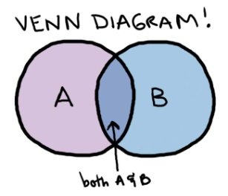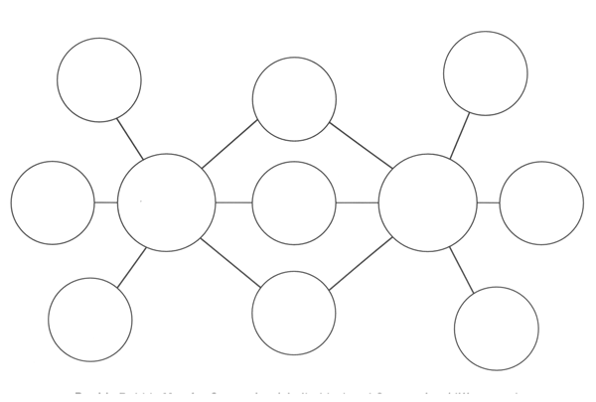  N: List of compare and contrast words/phrases  Compare Contrast  like, same, both, similarly, have in common, as well as, the same as, too although, however, but, differ, instead, unlike, even though, on the other hand  Thinking Skill: Comparing  - I find the items to compare. (boy in attic and apprentice)  - I choose features to compare the items. (appearance, personality, past, reactions, difficulties, etc)  - I tell how the items are the same or different.  a: Write paragraph comparing/contrasting characters of The Apprentice (Act. 2); students may want to complete Venn/Double-Bubble organizers first;  Goal: Reflective writing about “Why is comparing and contrasting a good reading strategy?” | Goal: Within the writing process, I can edit the mechanics of my writing. 5.L.2  APK: Discuss how each part of process is equally important  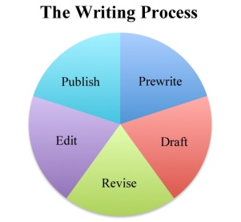  N: Make a list of “5th Grade Writers Will…” for mechanics (spelling, punctuation, formatting, and capitalization.)  a: Edit writings.  * Use comma to separate a series, an introductory element, “yes/no” a and a tag question.  *No-Excuse Words in notebook  Goal: Reflective writing “Why is editing a part of the writing process?”
Lesson 9 | Goal: I can decide on a research topic using a criteria-based process.  APK: YouTube video “The Invention of the World Wide Web”  N: Discuss list of famous inventors students may choose to research.  Thinking Skill: Decision Making  - I identify a decision that I need to make (inventor for research)  - I identify alternative choices to consider (choose 3 inventors to consider)  - I identify the characteristics to consider (effect of invention, interest in inventor/invention, availability of resources)  - I identify the importance of each characteristic (rate characteristics to consider 1-3)  - I identify the importance of each characteristic by each alternative to select the best (rate each inventor on its characteristic; multiply times rating of characteristic to get total score)  - If I need to, I change characteristics or value.  a: Decide on an inventor and provide reason for selection (Act. 6); Rate (1-5) each criteria for each inventor; add score; highest score is good indication of high interest, researchable topic;  Inventor/ Invention Effect Interest Resources Score  Value 1-3 Value 1-3 Value 1-3  Goal: Reflective writing about “Is criteria-based decision-making hard or easy? Why?”
Lesson 10 | Goal: I can integrate text from multiple sources in order to write about a subject knowledgably. 5.RI.9  APK: Question: How do you eat an elephant? Discuss how big project is completed a little at a time; don’t get overwhelmed; stay on top of the project and stay focused when it’s time to work;  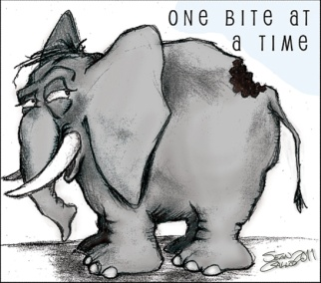  N: Research project criteria:  Answer research question: “How is necessity the mother of invention?”  3 sources (minimum)  Edited, revised essay  Multimedia element may be included  a: Brainstorm topics/questions to research (Act. 3 and 6)  Goal: Reflective writing about “Why do you think it’s important to collect information from many sources and not just one source?” | Writing notes

Lesson 11 | Goal: I can integrate text from multiple sources in order to write about a subject knowledgably. 5.RI.9 5.W.2  APK: Review note-taking skills (accuracy, quoting directly from text, adding thoughts/response)  N: Create graphic organizer to gather information about inventors  Research Question/Topic Response and Text  Question? Or Topic Book Title p. # “text” (- may include response to text)  a: Research and complete T-Chart with necessary information to answer questions (Act. 3 and 6)  Goal: Discuss “How does organizing your notes help you in research?”

Lesson 12 | Goal: I can integrate text from multiple sources in order to write and speak about a subject knowledgably. 5.RI.9 5.SL.1a  APK: YouTube “Timeline of Inventions that Changed the World”  N: Create timeline of inventors studied in order to understand where each inventor “lived” chronologically in history; post inventions/inventors on a timeline in classroom with major historical events/people/time periods already marked;  a: Discuss patterns/observations with a focus on how a necessity at the time prompted/encouraged the invention; (Act. 6)  Thinking Skill: Create an Argument  - I notice something and then make a statement about it that needs to be supported with more information  - I give examples and information to support my statement  - I give information that explains when my statement does not apply  Goal: Discuss “Is making your point easy or hard for you? Why? Why not?” | Goal: I can write an informative text to examine a topic and convey ideas and information clearly. 5.W.2  APK: Audi video (attention to detail)  N: Read an informative text about a researched topic, and identify why it is a quality piece.  a: Write an informative essay using the writing process and research notes to write an essay about an inventor.  Goal: Discuss “What’s the easiest part about writing informatively? The hardest?”
Lesson 13 | Goal: I can integrate text from multiple sources in order to speak about a subject knowledgably. 5.RI.9 5.SL.1a  APK: YouTube Video “Where Good Ideas come From?”  N: Discuss with class, “How would you define inventive thinkers?” using charts from Act. 3 and research notes  Possible answers: Someone who introduces something new or make changes in anything already made using a structured or unstructured purpose; someone who looks at problems/situations with an original solution;  a: Discuss with small group, “What are common characteristics of the creative/inventive thinkers studied?” using charts from Act. 3 and research notes to (Act. 4)  Possible characteristics: risk-taker, imaginative, curious, extending an idea, divergent/unique thinking, persistent, originality  Goal: Reflective writing about “What did you learn today about your thinking?” | Goal: I can write an informative text to examine a topic and convey ideas and information clearly. 5.W.2  APK: Informative signs to convey information  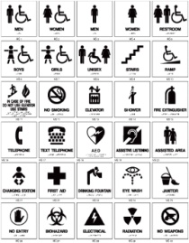  N: Review writing process.  a: Write an informative essay using the writing process in response to “How has inventive thinking, as revealed in fiction and non-fiction, changed our world?”  Goal: Discuss “How does the writing process make writing your essay easier?”
Lesson 14 | Goal: I can compare and contrast fiction and non-fiction and their approach to similar topics. 5.RL.9 5.SL.1  APK: YouTube “Leonardo da Vinci Inventions” and/or “BBC Leonardo The man Who Wanted to Know Everything (1 of 4)”  N: Read excerpts from Magic Tree House #19 Non-Fiction Guide about Leonardo da Vinci” and excerpts from Leonardo: Beautiful Dreamer. Take notes using a 3-Column T-Chart.  Topic MTH #19 Beautiful Dreamer  a: Discuss with class, “How does knowing the historical information enhance your understanding of the fictional story?” (Act. 5)  Goal: Reflective writing about “Do you like fiction or non-fiction better? Why?” | Write essay

Lesson 15 | Goal: I can explain the relationships between two or more events, ideas, or concepts in a text based on specific information in a text. 5.RI.3  APK: YouTube If You Don’t… commercial (cause/effect)  N: Organize the relationships of ideas in text with a flow chart.  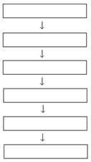  a: Reflect on one event, idea, or concept learned through research and using specific information, explain how the authors described/interpreted it the same or differently using a flow chart. (Act. 6)  Goal: Discuss “What did you learn today about cause and effect?” | Write essay
Lesson 16 | Goal: I can compare and contrast stories in the same genre. 5.RL.9  APK: Review compare/contrast signal words in notebook  N: Create story map of The Apprentice and include theme.  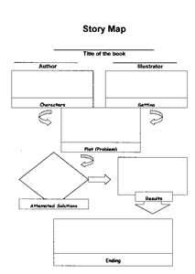  a: Create story map of the historical fiction read independently. Use compare/contrast words to write about the similarities and differences between the two texts and their approaches to theme. Students may draw a Venn or Double-Bubble diagram first.  Goal: Reflective writing about “How did comparing and contrasting help you as a reader?” | Write essay

