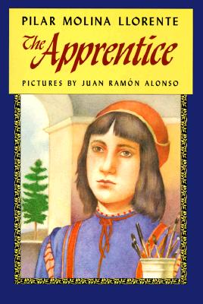5th Grade Whole Novel Study

The Apprentice, by Pilar Molina Llorent

This book takes place during the Renaissance in Florence,

Italy. It is the story of a 13 year old boy, Arduino, which comes from a family of tailors, who wants to become a painter. His father agrees to let him become an apprentice to a famous artist, Cosimo, for 3 years. Arduino discovers a mystery in Cosimo’s attic that occupies his time.

Items in your bag:

* Book
* Sticky notes
* Letter/calendar

Student Expectation:

* Read your assigned pages
* Be responsible for your materials
* Come to class ready for discussion

For ALL notes you must cite evidence from the text by giving a page number and a few short phrases. This will help you to remember where your notes have come from and you will be able to go back to these sections of text when we have our discussions.

|  |  |
| --- | --- |
| **Notes on…** | **Guidelines** |
| Main Characters | Using evidence from the text, investigate the characters in the story. When you meet a new character...   * What do you know about this character? His or her personality? * How does s/he act? * How does s/he connect to others? |
| “Give a thought”  Interesting/Curious Moments We Need to Discuss! | Take special notes on any parts in the book or thoughts you have while reading that would be good for bringing up in discussions. Put a star on this note to remind you to discuss it. |
| Characters Changing | When a character seems to be changing, write an observation or question about it.   * What action happened to make the character change? * Did your character’s traits have an impact on what happened in the story? |
| Vocabulary | What vocabulary words do you need to know to understand the message of the story?  Did you:   * Read the sentence more than once? * Re-read the word within the paragraph? Think about how the word is used in the sentence. * Look at the base word to see if you know any part of the word?   If you did these things and still do not know the word, look it up and write down the definition! |

This is your calendar of reading assignments. Mrs. Nelson and Mrs. Jones will expect you to have the chapters read on the specific day it is noted. You may read ahead as long as you are keeping up with your notes. We will be checking and scoring your notes and discussions.

|  |  |  |  |  |
| --- | --- | --- | --- | --- |
| Sept 30- October10 | | | |  |
| Monday 30th | Tuesday 1st | Wednesday 2nd | Thursday 3rd | Friday 4th |
| Introduction to text and procedures. | Chapters 1 & 2 | Chapters 1 & 2 | Chapters 3 & 4 | Chapter 5 |
| Monday 7th | Tuesday 8th | Wednesday 9th | Thursday 10th | Friday 11th |
| Chapters 6 & 7 | Chapters 8, 9 & 10 | Whole Group Discussion Days | |  |