*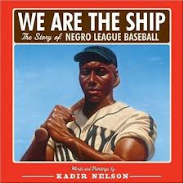We are the Ship*

Name:_________________________________ Teacher:_____________________

RL.5.2 Determine a *theme* of a story, drama, or poem from details in the text, including how characters in a story or drama respond to challenges or how the speaker in a poem *reflects* upon a topic; *summarize* the text.

|  |
| --- |
| What is the theme of the story? |
| How does the speaker reflect on the topic of the Negro Baseball League?  (what methods does he use to help you understand that time period and the situation?) |
| What is the summary of this story? |