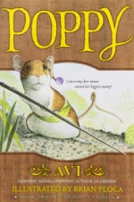**Characters: *Poppy***

**Character Description Picture**

|  |  |  |
| --- | --- | --- |
| **Mr. Ocax** |  |  |
| **Ragweed** |  |  |
| **Poppy** |  |  |
| **Lungwort** |  |  |
| **Sweet Cicely** |  |  |

What evidence from the text helped you describe one of the characters?

Character: ________________________________ Page number:_______

Text Evidence**:____________________________________________________**

**________________________________________________________________________________________________________________________________________________________________________________________________________________________________________________________________________**