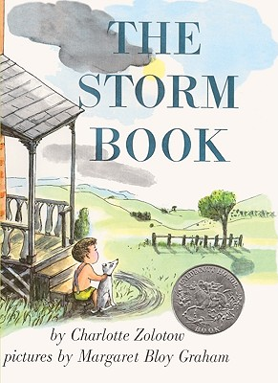

**parched**

**straining**

**tremendous**

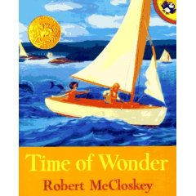

**jagged**

**acrobatic**

**unfurling**

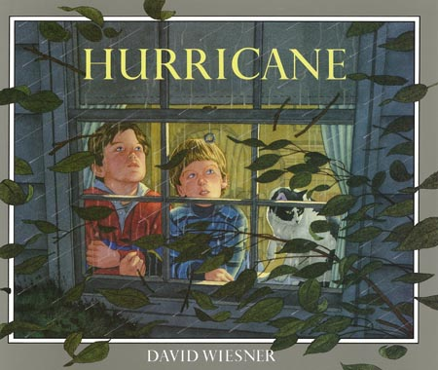

**securing**

**peered**

**gusting**

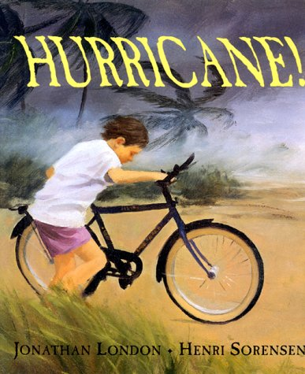

**scorpion**

**waded**

**thrashed**

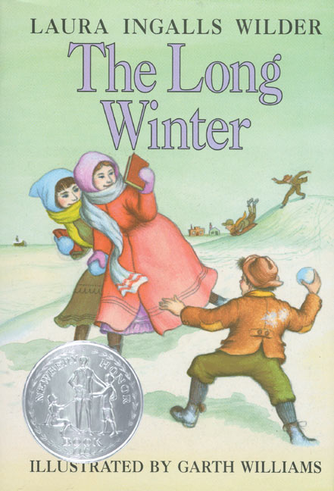

**eagerly**

**marshy**

**sober**

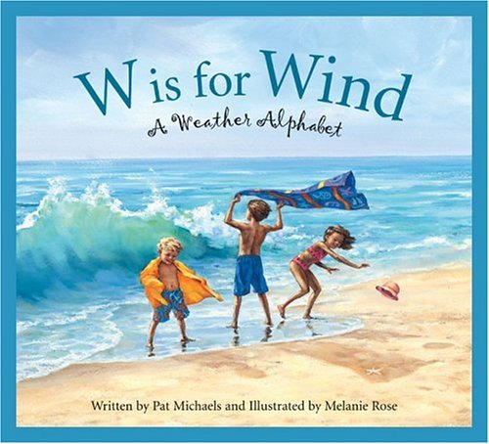

**coats**

**fierce**

**glittering**