Cirrus clouds are thin, wispy, high level clouds formed of ice crystals. Cirrus clouds often develop twenty to thirty hours before the arrival of a warm front and are a good forecaster of unsettled weather to come. Cirrostratus is another

high –level cloud formed of ice http://www.weatherwizkids.com/weather-clouds.htm crystals. These veil-like clouds are so thin that blue skies or bright stars often show through them.

**Cirrus Clouds taken from** [**http://www.weatherwizkids.com/weather-clouds.htm**](http://www.weatherwizkids.com/weather-clouds.htm)

**Cirrus clouds** are the most common of the high clouds. They are composed of ice and are thin, wispy clouds blown in high winds into long streamers. Cirrus clouds are usually white and predict fair to pleasant weather. By watching the movement of cirrus clouds you can tell from which direction weather is approaching. When you see cirrus clouds, it usually indicates that a change in the weather will occur within 24 hours.  
[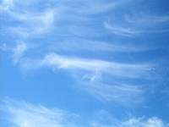](javascript:Start('cirrus.jpg'))  
  
**Cirrostratus clouds** are thin, sheet-like high clouds that often cover the entire sky. They are so thin that the sun and moon can be seen through them. Cirrostratus clouds usually come 12-24 hours before a rain or snow storm.  
[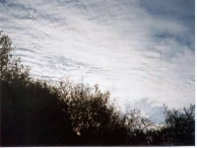](javascript:Start('cirrostratus.jpg')) [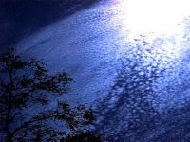](javascript:Start('cirrocumulus.jpg'))   
  
**Cirrocumulus clouds** appear as small, rounded white puffs that appear in long rows. The small ripples in the cirrocumulus clouds sometime resemble the scales of a fish. Cirrocumulus clouds are usually seen in the winter and indicate fair, but cold weather. In tropical regions, they may indicate an approaching hurricane.