**RL.4.3 Describe in depth a character, setting, or event in a story or drama, drawing on specific details in the text (e.g., a character’s thoughts, words, or actions)**

**L.4.4.a. Use context (e.g., definitions, examples, or restatements in text) as a clue to the meaning of a word or phrase**

**“I can describe Pete Bruce using specific details from the text”**

**“I can use context clues to help me figure out the meaning of unknown words or phrases”**

Text-“When Pete Bruce Came to Town” from Porch Lies; Tales of Slicksters, Tricksters, and Other Wily Characters by Patricia C. McKissack

Prior to this lesson:

Watch Brer Rabbit Runs Away <http://www.youtube.com/watch?v=8ICFIlsUlGg>

Read the “Author’s Note” aloud to the class. Give them the following exit card:

EXIT CARD- Jot down what you think the following words or phrases mean:

wily character

silver tongue

**TIERED ASSIGNMENTS**

Based on the student responses and your knowledge of the students, choose the appropriate response journal prompt.

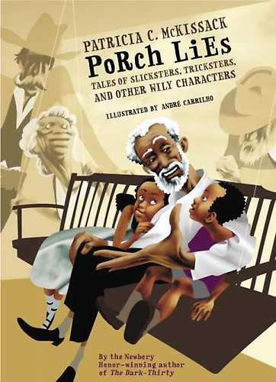For students who don’t know what wily means:

Look at these images of “wily”. Talk with a partner about what you think “wily” might mean.

Read the sentence from the Author’s Note:

*I was especially delighted when the story was a slickster-trickster tale about some wily character who used his wits to outsmart his opponents.*

Talk with a partner about what you think “wily” means now.

Describe Pete Bruce.

Include his physical appearance as well as his character traits.

You can use drawings and labels or write a series of paragraphs.

Do you think Pete Bruce is wily? Why or why not?

For those students who seem to grasp the meaning of wily, but are not clear about the phrase, “silver tongue”:

Read the excerpt from the “Author’s Note”. What clues in the excerpt could help you understand the meaning of the phrase “silver tongue”?

Talk with a partner about what you think the phrase means.

Look up the definition on the computer.

Describe Pete Bruce.

Include his physical appearance as well as his character traits.

You can use drawings and labels or write a series of paragraphs.

Do you think Pete Bruce has a silver tongue? Why or why not?

For students with advanced skills in vocabulary:

Describe Pete Bruce.

Include his physical appearance as well as his character traits.

You can use drawings and labels or write a series of paragraphs.

Why do you think Patricia McKissack describes her trickster characters as “*gifted with a silver tongue tarnished by an oily reputation*”?

Does this description fit Pete Bruce? Why or why not?

What other words could you use to describe Pete Bruce?