Olympic Games- Then and Now
 | Who participates? | What do they do (events)? | Where do they compete?
First Olympics
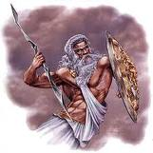
Early Olympics
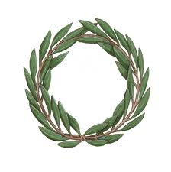
Modern Olympics
