*Read the passage. Then answer multiple-choice questions 1 through 8 and the open-response question.*

**Rat Stew**

An excerpt from It’s Disgusting and We Ate It!: True Food Facts From Around the World and Throughout History

by James Solheim

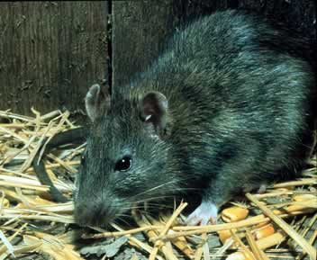

**2**

Columbus’s son wrote of sailors waiting until dark to eat their biscuits – to keep from seeing worms crawling in them. A crewman on another explorer’s ship told of sailors eating sawdust and sharks when their food ran out.

That was ship life before refrigerators. Every bit of the ship’s food spoiled long before the ship could reach shore. If anybody caught a fish it was rotten by the next day. Fortunately, packs of rats lived on ships. Crew members paid the ship’s rat catcher high prices for rats because that was the best food they had left!

**Time for Ye Old Poem:**

**SEAFOOD MAKES ME SICK**

after eight weeks at sea

the rats start looking good

diced small drowned in gravy

they almost pass for food

we shut our eyes and try to think

one word

“venison”

**1**

**Great Rat Cooking Starts**

**with Quality Rats**

The world’s most famous dictionary of French food says that meat from a well-fed rat can be quite good – despite an occasional musky flavor. In fact, the people who made barrels for France’s wine loved to eat a good quality rat. They grilled rats grown fat on fine Bordeaux wine, using broken barrels for fuel.

**The World of Rodents International Dining Club**

Some ancient Chinese ate live baby rats, while ancient Romans relished stuffed dormouse (a tree-climbing rat relative). South America’s Incas ate guinea pigs, and invading Europeans liked them too.

But it wasn’t just the ancients who enjoyed a steaming bowl of rodent stew. Many Americans today eat squirrels – cousins to the furry heroes who saved sailors with their meat and made emperors call for more.

**3**

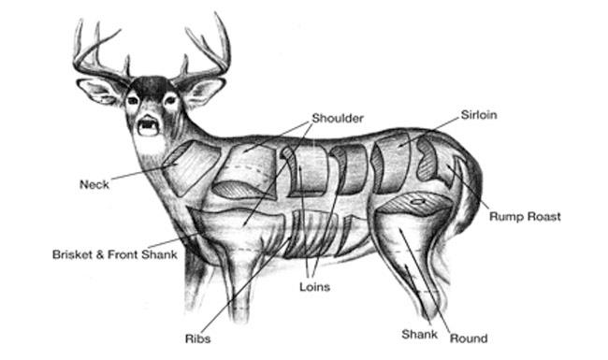

Venison is deer meat. A European sailor might well have tried to imagine this noble food in his stew – since eating it was often illegal in his homeland.

**5**

 

**7**

**Make Way for Muskrats**

In a recent year, trappers caught more than 400,000 muskrats in New Jersey alone. Most trappers threw away the meat and sold the fur for a few dollars.

What a waste! One adventurous trapper compared muskrat’s flavor to beef, and said he preferred it to rabbit. Muskrat is a traditional food in parts of Canada and Cajun country.

**Menu**

**No substitutions Tails 99¢ extra**

**Sun-dried salted rat meat**

**(China)**

**Roasted or fried rice rats**

**(Thailand)**

**Stewed cane rat with tomatoes and**

**hot red peppers**

**(Ghana, in Africa)**

**Rats deep-fried in coconut oil**

**(The Philippines)**

**Rat stuffed with donkey meat**

**and fat**

**(France during the**

**Franco-Prussian**

**War, 1870-1871)**

1

3

In paragraph 3, the reader can tell something that is musky –

**A** is furry.

**B** tastes good.

**C** has a strong odor.

**D** has no taste.

The author probably included the poem “Seafood Makes Me Sick”, because it –

**A** helps the reader see how hard ship life was.

**B** shows how poems were popular on ships.

**C** tells the reader about sickness on the ship.

**D** teaches the reader how to cook rats.

The author most likely wrote this passage to –

**A** teach you how to make rat stew.

**B** give facts about people who have eaten rats.

**C** help protect rats and other rodents.

**D** tell how to choose a rat for a pet.

In paragraph 2, the pronoun it refers to –

**A** a rat

**B** the ship

**C** a sailor

**D** a fish

2

4

5

In which area of the library would this passage be found?

**A** reference

**B** fiction

**C** nonfiction

**D** biography

Why didn’t European sailors eat deer meat in their homes?

**A** Deer meat is not healthy.

**B** It was often illegal to eat deer meat.

**C** They didn’t know how to hunt for deer.

**D** There are no deer in Europe.

7

On the menu shown, which dish was served in the Philippines?

**A** Sun-dried salted rat meat

**B** Rats deep-fried in coconut oil

**C** Rat stuffed with donkey meat and fat

**D** Roasted or fried rice rats

In paragraph 5, the ancients are people who –

**A** ate rats every day.

**B** sailed on ships for many months.

**C** opened restaurants that served rat.

**D** lived a long time ago.

6

8

A rat is just one kind of rodent. Name four other rodents mentioned in the passage that people eat

or have eaten.

|  |
| --- |
| **________________________________________________**  **________________________________________________**  **________________________________________________**  **________________________________________________**  **________________________________________________** |

This passage was taken from the book, It’s Disgusting and We Ate It! Whether eating rats sounds delicious or disgusting to someone depends on different factors. Name some reasons a person might

want to eat rat stew.

People in different countries around the world enjoy different foods. What has this passage taught you about the food people choose to eat?

|  |
| --- |
| **________________________________________________**  **________________________________________________**  **________________________________________________**  **________________________________________________**  **________________________________________________** |