Molly’s Pilgrim
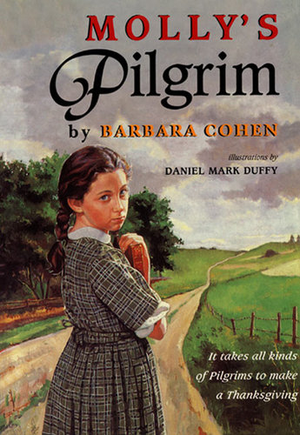

By Barbara Cohen
ISBN: 9780688162801

Ideas for the Classroom
Connecting to Common Core Anchor Standards:
Analyze how Molly’s relationship with other students in the class has developed and changed throughout the text. (3)
Integrate diverse media. (7)
Evaluate the claims in the text and apply the character traits of the original pilgrims to pilgrims of today. (8)
Helpful Links:
- "Pilgrimage" History for Kids
- "Pilgrimage" Kids Past
- Pilgrimage for Kids- images
- "They Were The Pilgrims" Music Video
- Molly's Pilgrim Video Clip
Thematic Ideas: individuality, pilgrimage, and freedom
Comprehension Strategy:
Determining importance -What lesson can we learn from Molly?
Connections- How is Molly like the Thanksgiving pilgrims?
Companion Books:
- Cathedral: The Story Of Its Construction
- The Long Way To A New Land
- The Keeping Quilt
- Watch The Stars Come Out

Hook Your Students
- Molly has a hard time fitting in with the girls in her class.
- Barbara Cohen also wrote a historical fiction book about Jackie Robinson.
- This story will make you think differently about Thanksgiving.

Qualitative Measures | Quantitative Measures
Point of View/Perspective | Leveling System Level Grade(s)  Lexile Level  Guided Reading  ATOS Level  ATOS Points  DRP Level  Interest Level  Page Count  Copyright Date  Series  Awards
This story is told from the point of view of Molly, a third grader originally from Russia. This is the story of her journey of acceptance.
Structure
This short novel is written in narrative form with soft illustrations spread throughout. It is told in chronological order beginning with Molly’s assignment to create the doll to the reactions after she brings in her unique pilgrim.
Language Convention and Clarity
The language is direct and clear with dialogue that adds to the emotion of the story. Molly’s voice is innocent and sincere, and the reader empathizes with her to the end.
Demands of Prior Knowledge
It would be helpful for students to know the story of the first Thanksgiving to better understand Molly’s worries and concerns about how the class would react to her doll.
Differences between Christianity and Judaism are implied as being another reason Molly feels left out. Russian and Jewish terms such as tabernacles and synagogue and are used throughout the text, but they are described through context.
Levels of Meaning
Molly’s differences make her the target of mockery. But with the help of her teacher, her classmates come to see they have more in common than they originally thought. In addition to being a story of pilgrimage and freedom, this is also a story of acceptance.

Possible Big Idea: Pilgrimage and freedom
Possible Essential Question Who are modern pilgrims of today?

