|  |  |  |
| --- | --- | --- |
| Quality | Rachel | Grisha |
| Traits | * Kind * Loves her cousin * Story teller * Understanding * Problem solver | * Grieving * Loves his cousin * Illustrator * Keeps feelings to himself * Orphan |
| Motivations | * Happiness * Safety * Life * Staying with family * Saving Grisha | * Happiness * Safety * Life * Staying with family |
| Feelings | * Happy with Grisha * Scared to leave * Sacred to stay in Russia * Determined | * Happy with Rachel * Scared to leave * Scared to stay in Russia * Grief |

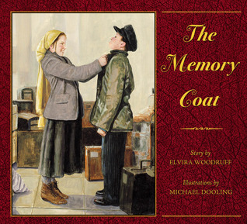

Complete the chart for Rachel and Grisha from The Memory Coat

**Possible answers…there are others that would be acceptable.**

Describe Rachel. Support with evidence for the text.

Rachel is very kind, caring, and understanding. She loves to tell stories and spend time with her cousin Grisha.

Share one example of how Rachel’s actions contributed to the sequence of events in the story? Use a specific action to justify your answer.

After Grisha had the “E” written in chalk on his coat, he was not going to be allowed to enter America with his family. Rachel told him to turn his coat inside out. When Grisha went through a different line and saw a different doctor, he was cleared to enter America. Rachel’s action helped Grisha pass the test and helped keep her family all together.

Describe Grisha.

Grisha was orphaned when his parents died. He was still grieving their loss. He enjoyed spending time with his cousin (and best friend), Rachel. He was loved to draw pictures of the stories that Rachel told.

Share one example of how Grisha’s actions contributed to the sequence of events in the story? Use a specific action to justify your answer.

When Bubba wanted to make a new coat for Grisha, he said, “NO!” and ran away. This action caused the rest of his family to understand how he was feeling. They did not try to replace his old coat again.