|  |  |  |
| --- | --- | --- |
| Quality | Rachel | Grisha |
| Traits  A person’s personality or attitude |  |  |
| Motivations  The reason we act the way we do |  |  |
| Feelings  How we feel  about things |  |  |

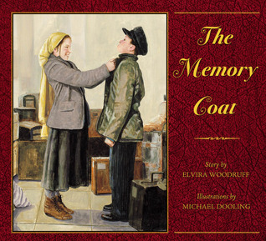

Complete the chart for Rachel and Grisha from The Memory Coat

Describe Rachel.

_________________________________________________________________________________________________________________________________________________________________________________________________________________________________________________________________________________________________________________________________________________________

Share one example of how Rachel’s actions contributed to the sequence of events in the story? Use a specific action to justify your answer.

_________________________________________________________________________________________________________________________________________________________________________________________________________________________________________________________________________________________________________________________________________________________

Describe Grisha.

_________________________________________________________________________________________________________________________________________________________________________________________________________________________________________________________________________________________________________________________________________________________

Share one example of how Grisha’s actions contributed to the sequence of events in the story? Use a specific action to justify your answer.

_________________________________________________________________________________________________________________________________________________________________________________________________________________________________________________________________________________________________________________________________________________________